Thu, Feb 28 2013 12:56 PM ET

THE BULL MARKET IN GOLD MAY BE OVER -- LONG-TERM TECHNICAL INDICATORS WEAKEN -- A STRONG DOLLAR, STRONGER STOCKS, AND WEAK GOLD MINERS ARE ALSO BAD FOR GOLD -- LONG-TERM RATIO ANALYSIS FAVORS STOCKS OVER COMMODITIES -- A FIRMER DOLLAR ALSO FAVORS U.S. STOCKS OVER FOREIGN STOCKS
By John Murphy
LONG-TERM INDICATORS ARE ROLLING OVER... A lot of traders and investors are waiting for the bull market in gold to resume. They may have a very long wait. That's because a lot of traditional chart, technical, and intermarket signs are now working against gold. Let's start with a long-term look. The monthly bars in Chart 1 show the major bull move in gold that lasted from 2001 to 2011. The rising trendline drawn on the log chart is still intact. [A log price scale measures percentage price changes and is better for long-term trendline analysis]. But the two indicators shown on the chart aren't. The orange line overlaid on the gold price is the 14-month RSI line which measures long-term market momentum. The last major peak in the RSI took place during 2011. The fact that it fell short of its 2008 peak formed a "negative divergence" with gold. Even worse, the RSI line has been dropping since 2011 (orange trendline). The RSI line is now approaching an important test of its 2008 low (dashed line). It it doesn't hold there, the long-term trend of gold should weaken further. The monthly MACD lines (top of chart) look even worse. The two lines turned negative at the start of 2012 (red arrow) and have fallen to the lowest level in three years. That's the worst downturn by the MACD lines since the bull market began in 2001.
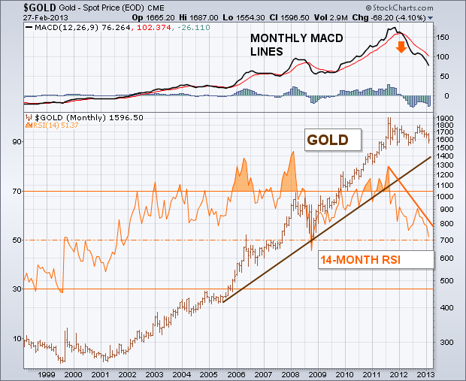
(click to view a live version of this chart)
Chart 1
WEEKLY MACD LINES TUMBLE AS GOLD TESTS SUPPORT... The weekly bars in Chart 2 show the price of gold testing the lower end of an eighteen-month trading range. That's a logical spot to expect gold to attempt a rally. Even if gold rallies, it would need to clear resistance along the $1800 level to resume its uptrend. Unfortunately, any bullish analysis is undercut by the unusual fall in the weekly MACD lines. The two lines peaked during 2011 and have fallen sharply since then. That created a huge negative divergence by the MACD lines and bullion. Chart 3 shows how big a negative divergence that is. The weekly MACD lines broke their major up trendline during 2011 and have plunged since then. That certainly seems to argue that the bull market has run its course. Needless to say, any drop by gold below the lower trendline (just below $1550) would confirm a new downtrend.
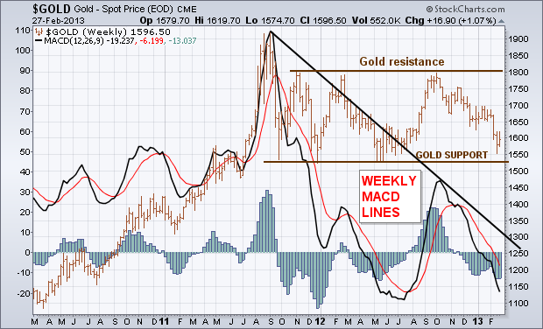
(click to view a live version of this chart)
Chart 2
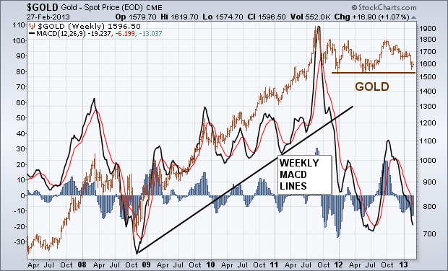
(click to view a live version of this chart)
Chart 3
GOLD MINERS FALL TO NEARLY FOUR-YEAR LOW... Another factor weighing against bullion is the drop in gold mining shares over the last two years. The weekly bars in Chart 4 show the Gold Miners Index (GDM) having broken previous chart support along its 2010 - 2012 lows to drop to the lowest level since 2009. That also creates a huge negative divergence between gold miners and the price of gold (brown line). Since the two markets have historically been positively correlated, the chart breakdown in gold miners is another strike against the bull market in gold resuming. Chart 5 shows the positive correlation between gold miners (orange bars) and gold (brown line) over the last twenty years. They generally rise and fall together. The solid area plots a relative strength ratio of the Gold Miners Index (GDM) divided by the price of gold. The ratio has now fallen to the lowest level since the bull market in gold started more than a decade ago. Something has to change here. Either the miners have to start rallying, or gold will most likely follow them lower.
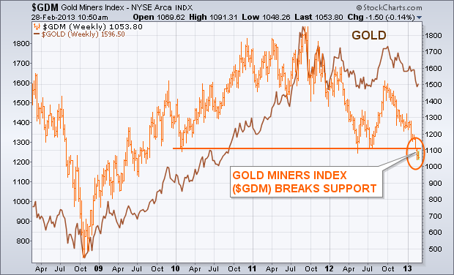
(click to view a live version of this chart)
Chart 4
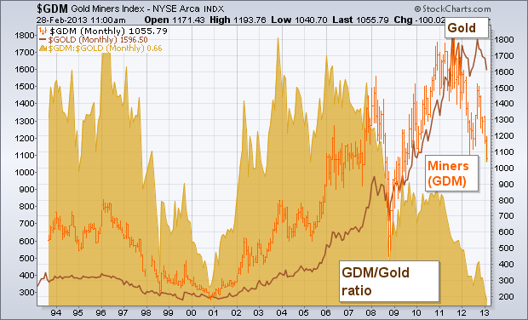
(click to view a live version of this chart)
Chart 5
FIRMER DOLLAR WEAKENS COMMODITY OUTLOOK... Another factor working against gold is new stability in the U.S. Dollar which usually works against commodity price trends. The monthly bars in Chart 6 show that the bull market in gold (and other commodities) started during 2002 when the U.S. Dollar Index started a major decline. A falling dollar is bullish for commodities. Since 2008, however, the Dollar Index has been trading sidways in a potential bottoming pattern. The 2008 and 2011 upturns in the dollar caused selloffs in the CRB Index (see arrows). Gold has held up much better than most commodities since 2008 because of its safe haven characteristics. If the dollar keeps bouncing, and most other commodities keep dropping, however, it's doubtful that gold can buck both of those negative intermarket trends.
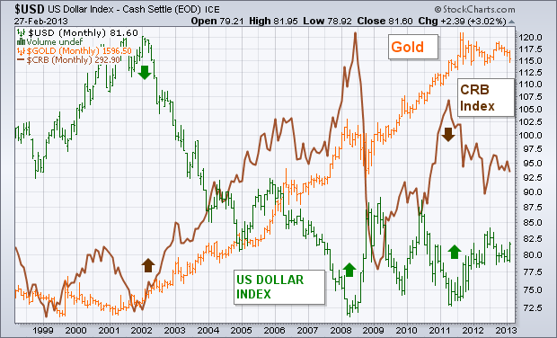
(click to view a live version of this chart)
Chart 6
NEW BULL MARKET IN STOCKS WOULD HURT GOLD... My Market Message from February 2 carried a headline that read: "Stronger Stock Prices are Diminishing the Appeal of Gold." That message showed the rising of price of gold over the last decade coinciding with a huge trading range ("the lost decade") in stocks. I showed that the bull market in gold started shortly after stocks started to tumble between 2000 and 2002. I further suggested that a new record high by stock prices would diminish the appeal of gold. Chart 7 compares the two assets over the last three decades starting in 1980. During the two decades between 1980 and 2000, falling gold prices coincided with a secular bull market in stocks. The ending of the bull market in stocks during 2000 helped launch a major bull market in gold. Chart 7 shows the S&P 500 nearing a test of the top of that decade-long trading range. A new high by the S&P would most likely signal a new secular bull market in stocks. That would reduce the need to hold gold.
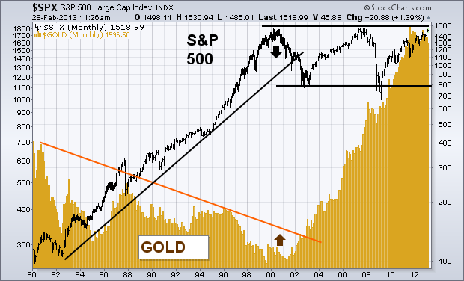
(click to view a live version of this chart)
Chart 7
DOW/GOLD RATIO TURNS IN FAVOR OF STOCKS... My February 2 message also showed a falling Dow Industrial/ gold ratio favoring gold over the last decade. There are early signs that the ratio may be turning up in favor of stocks. Chart 8 plots the Dow/gold ratio since 2006. Between 2007 and 2011, the falling ratio favored gold over stocks. Since the second half of 2011, however, the rising ratio has favored stocks over gold. I suspect that the ratio will rise a lot further if and when the S&P 500 is able to break out of its major trading range and sets a new record.
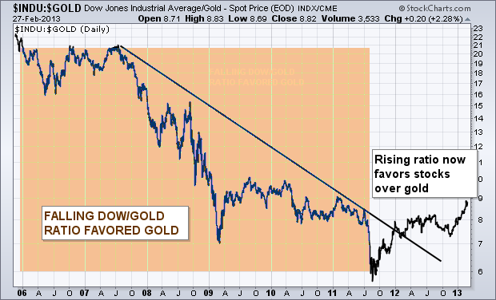
(click to view a live version of this chart)
Chart 8
SECULAR TREND FAVORS STOCKS OVER COMMODITIES ... I recently wrote a message showing that stocks have been rising faster than Treasury bonds since 2009, and suggested that a long-term asset allocation rotation was starting which favored stocks over bonds. The same is true with stocks versus commodities. Chart 9 is a relative strength ratio of the S&P 500 divided by the CRB Index of commodity prices since 1999. The falling ratio favored commodities prices between 2000 and 2008 before bottoming. The ratio has been rising since 2008 and has reached a ten-year high. That suggests the decade of commodity leadership has ended, and that the long-term pendulum now favors stocks over commodities. I suspect that a stronger U.S. dollar has a lot to do with that.
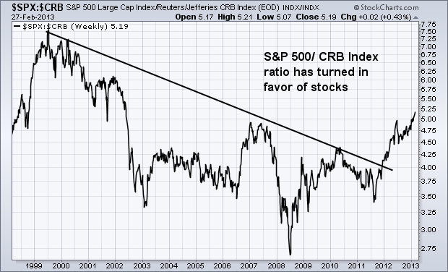
(click to view a live version of this chart)
Chart 9
STRONGER DOLLAR FAVORS US STOCKS... Not only does a stronger U.S. dollar favor stocks over commodities. It also favors U.S. stocks over foreign stocks. The black line in Chart 10 is ratio of the S&P 500 (representing the U.S.) divided by the MS World ex USA Stock Index ($MSWORLD). The green area represents the trend of the U.S. Dollar Index. One of the intermarket rules that governs global trading is that a weaker U.S. dollar causes foreign stocks to outperform U.S. stocks. That was the case between 2002 and 2008 when a falling dollar coincided with a falling U.S./foreign stock ratio. The ratio bottomed with the dollar during 2008 and has now risen to the highest level in five years. That's because a firmer dollar favors U.S. over foreign stocks.
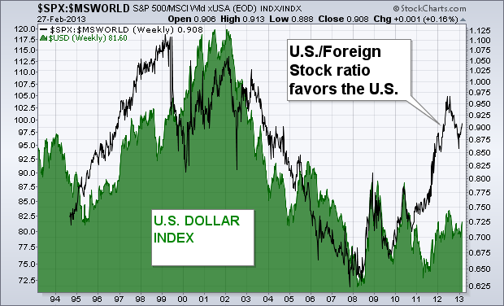
(click to view a live version of this chart)
Chart 10
THE BOTTOM LINE... My latest book entitled "Trading with Intermarket Analysis" described how deflationary trends since 2000 contributed to a "lost decade" in stocks and helped launch major bull markets in bonds and gold. The book also described early signs that stocks might be emerging from that lost decade which would make stocks the most favored asset class in the year's ahead. This message shows several long-term charts in favor of that hypothesis. A deflationary period favors gold and bonds over stocks. A more reflationary period favors stocks over other asset classes. A shift has already begun out of bonds into stocks. The Fed may delay the rotation from bonds to stocks, but can't prevent it indefinitely. A firmer dollar favors stocks over commodities. A firmer dollar also favors U.S. stocks over foreign stocks. In my view, the key to these changing intermarket trends is the ability of the S&P 500 to break out of its twelve-year trading range to reach a new record high. It may have some trouble doing so over the short run as it approaches its 2000-2007 highs in an over-extended condition. But I believe the odds are good that it will break through eventually.

