Navigating Range-Bound Markets with Longer Investment Time Frames
Mike Scott
8/24/2016

Introduction
It has been difficult to remain solvent in the market since early 2015. In my experience, most people have struggled unsuccessfully in this period. Breakouts often fail, and stocks stay around their price for longer periods. This white paper presents a method for navigating this type of market with a step by step set of investing rules. The rules discussed here operate over many months with few signals. As with any system, losses will occur. The hallmark of the system is that you will likely hold stocks retained in the portfolio for many months.

Current Market
Many know that Investor’s Business Daily restructured their business. Operating a daily newspaper is an expensive proposition as the pages don’t write themselves. I believe that the bulk of the readership became disenchanted with the market and the system they follow. Indeed, it has been difficult to remain fully engaged in the market, even for the professionals. Range-bound markets don’t offer the same opportunities such as experienced in the 1990s where one could throw darts at the stock listings and be successful. In response to the market, people often go on a search for a new system, shorten their investment time frame or discover options. I have done this in the past with bad results. If you can’t make money in a cash market, increasing leverage won’t help and jumping onto the system du jour probably won’t help either. I no longer search for a new system. However, I continually try to improve the system in which I am already familiar. I stick to a set of rules that I know work. No system works well in all market conditions; this means that sometimes I just have to wait for favorable conditions to return.
Many of us have been waiting for the big market washout that usually follows a long-term market rise. Indeed, we are more than seven years since the 2009 market bottom. I was expecting a normal bear market to come at any time. However, another possibility exists that we will not experience a big decline, but a long period of sideways action. Washouts scare people out of the market; range-bound markets wear people out of the market. We may have started that sideways period in 2015.
I believe Pascal Willain properly captured the current market theme by noting that the US market has remained buoyant because of the Central Bank policies of Europe and Japan. Negative Treasury rates in these countries have created a belief that the US market is the only market left with potential. Given that central bankers all subscribe to Lord John Maynard Keynes; I expect that their policies will be slow to change. Negative Interest Rate Policy is the basis for believing that we are in a market phase that will remain the same until another crisis develops.

Use of the Coppock Curve for gauging secular market Changes
Edwin Coppock first published a technique for gauging a shift from a bear market to a bull market in Barons magazine on October 15, 1962. He developed a momentum indicator on a monthly time scale. The indicator is the sum of a 14-month rate of change and an 11-month rate of change, smoothed by a 10-period weighted moving average.$$Coppock=WMA\left[10\right] of (ROC\left[14\right]+ROC\left[11\right])$$
The Coppock buy signal occurs when the indicator is below zero and turns upward from a trough. Shown below are three monthly Coppock Curves, one each for the NASDAQ, S&P, and Dow market indices. Clearly shown is the secular market shift in 2009 with the deep trough and subsequent upward turn. Also shown near the vertical cursor is a shallow trough below zero and upward turn, could this be the announcement of another secular market change? What I do, is go with the ebb and flow of the market and follow the system in which I have become comfortable.

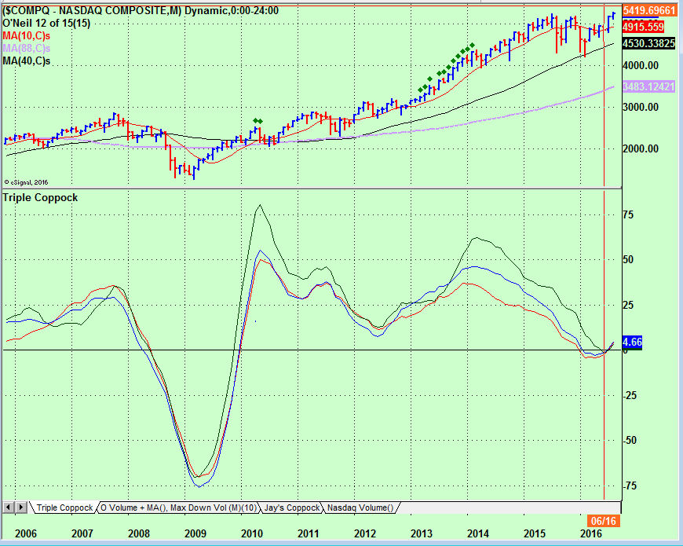
I certainly do not know that the current market will have legs, but the Negative Interest Rate Policy probably does have legs.
In the curve above, the buy signal is in the middle of this year. Jerry Samet adopted a useful modification of the Coppock Buy Signal approach by shifting to a weekly time frame using the same algorithm. When he becomes aware of a trough forming in the negative half plane, he shifts to the weekly view to fine tune the decision point. Shown below is the Weekly Coppock showing a buy signal around late February of this year. The title of this paper suggests we are in a range-bound market, which we have been. The preceding analysis suggests that this could enter a new regime.
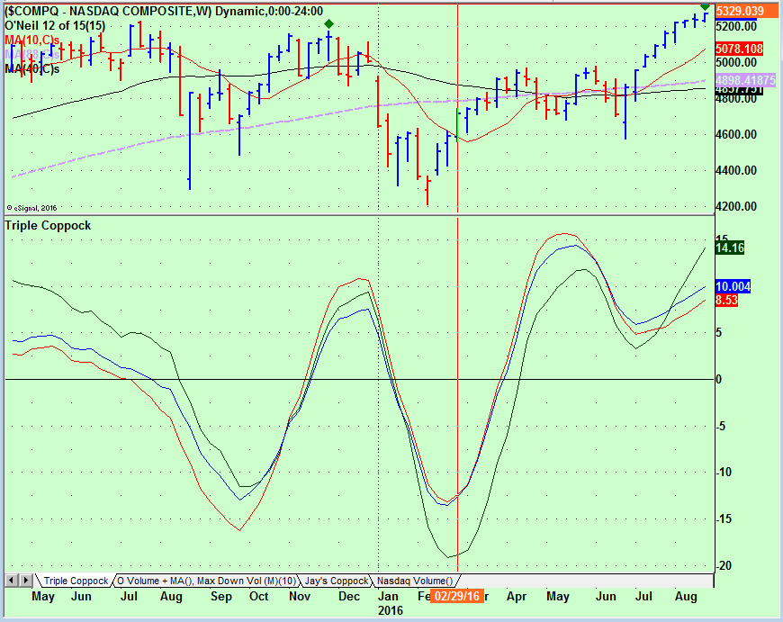
No indicator is perfect, and the Coppock Indicator has its misses, but in general when it misses it is followed up by a hit. For those who wish to follow this curve, go to Freestockcharts.com where the Coppock is one of the supported indicators. Stockcharts.com also supports the Coppock curve but only for time scales of daily and weekly charts.

The Need for a Simple System
There are few people who can successfully navigate the market without a robust system of rules that they religiously follow. Most people fail in the market. Bill O’Neil is one of the best traders that have ever navigated the market. He has been generous in sharing his knowledge. Most who have become aware of CANSLIM methods is from his book How to Make Money in Stocks by William J. O’Neil.
People who try to follow any investing system tend to overtrade initially. Within the CANSLIM trading system, I believe the many buy and sell rules developed leads to a confusion factor with overtrading as a result. O’Neil is highly contextual and as such knows when to apply his rules and when to sit. Reading the market to the skill level of O’Neil takes a lifetime. Indescrimanantly used rules usually, leads to overtrading. Overtrading in a range-bound market is a recipe for losses.
A sharply trending market can mask many trading faults; range-bound markets will uncover them. When I mentor individuals, I make them produce a written trading plan. I then ask them to follow their plan. If the plan is not returning the desired results, I suggest they figure out why and modify the plan and then trade that plan. There is a need for a simple set of rules that if followed will produce success. One can add complexity in the fullness of time as long as your system is producing today.
Meet Ashish Dave. Ashish is an engineering manager for one of the silicon valley companies, i.e., he has a day job and can not afford to monitor the market all day. He needs a system where he can only monitor the open and the close. He developed and backtested a simple of set rules containing one buy rule and six sell rules that he profitably uses to operate his portfolio.

Buy Rule
Study the possible buy candidates by looking at their fundamentals and proximity to a classical buy point. A classical buy point is the pivot price of standard bases such as a cup and handle, double bottom, flat base, etc. The pivot price for a cup and handle base is the high of the handle formation. The pivot price of a double bottom base is the high of the midpoint of the base, the pivot price of a flat base is the highest price in the base. The stocks that meet your fundamental screen and that could break out above a pivot point in the coming days go on your watch list. The buy rule then becomes: buy a stock on your watch list at the pivot or as close as possible if the breakout volume exceeds 100% above 50-day average volume. Do not purchase positions if their next earnings release is during the current week.
It can be difficult to judge volume during the trading day. In the appendix is a table that one can use to project current real-time volume to End-of-Day (EOD) volume. For example, the multiplier three hours into the trading day is approximately 2, indicating that if the volume is equal to the average volume at this time, the volume is on a trajectory to achieve double the average or 100% above average volume.
Members who have subscribed to the High Growth Stock portion of the Effective Volume site have additional tools to gauge volume with real-time EOD volume extrapolation.

Sell Rules
This section lays out a set of six sell rules, largely developed by Ashish Dave. Modifications to Ashish’s rules have been developed to accommodate gap-up and IPO buying. Intended in this paper is that all sell rules are to be executed at the EOD or end of the week (usually Friday). In this section holding period is the number of weeks the position you hold the position, with week one being the purchase week.

Sell at the EOD if the price closes 5.5% below the pivot price
At the end of the day, sell positions that close 5.5% or more below their pivot price. Apply this rule daily to positions held during the first seven weeks. Other rules will supersede this rule for longer holding periods. Once you hold a position til the end of the week, this rule seldom applies.

Sell at the end of week if the Friday price closes below the pivot price
At the close of the week, sell positions that close below their pivot price. This rule applies during the first seven holding weeks. Other rules will supersede this rule for longer holding periods. Institutions defend their positions with price supporting actions. A stock that does not hold the breakout pivot can be an early sign of future failure.

Sell the day before earnings announcement if you do not hold a 5% profit
Apply this rule at the end of the day to positions held during the second through seventh holding weeks. Other rules will supersede this rule for longer holding periods. Do not purchase stocks if the earnings release is in the current week.

Sell at the end of the week if the position does not have 8% profit
Apply this rule to holding week eight or later. Once you have held the position longer, you expect the price to increase. If the position has not increased by at least 8% by the end of week eight, sell and redeploy your money into faster opportunities.
Exception to rule 8% profit rule
Consider not executing this rule if the stock exhibits any of the following characteristics.
- Stock closed up five weeks in a row anywhere since the bottom of the base
- Price after the breakout never closed below the 10-week moving average
- Price achieved 20% or more gains after the breakout
- Earnings and sales have accelerated over the last three reporting periods

Sell at the end of week if price closes below the 10-week moving average on above-average volume
Apply this rule to holding week 9 and later. This sell rule will be the common profit taking signal for positions held longer-term.

Sell stocks exhibiting the largest weekly volume since the beginning of the advance
Apply this sell rule to positions held 18-weeks or longer. After a significant advance, stocks showing extremely high volume are possibly showing climactic activity. Stocks that show high volume less than 18-weeks from a 1st or 2nd stage base breakout are usually not showing climactic activity but probably just continuing their breakout run.
Exception to rule
If after selling a stock using this rule, buy the stock back in the very next week if it closes above the 10-week moving average.

Sell rule time frames summary

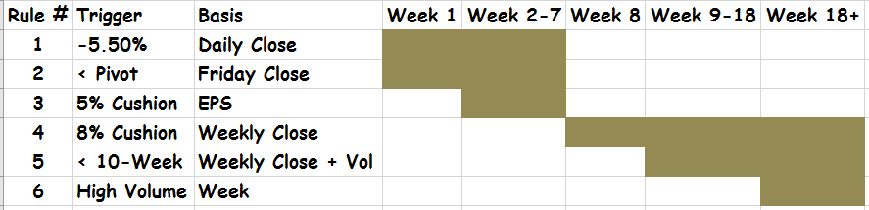

Special Circumstances

Initial Public Offerings (IPOs)
IPOs can offer lucrative opportunities. They don’t always form a legal base before breaking out. A cup and handle or double bottom base normally require seven weeks to form a proper base. IPOs often will not wait this long before they make their move. Study GOOGL at its three-week long IPO base in 2004; this is the quintessential example of a short IPO base and breakout. The characteristics of a sound IPO base is that it remains above the IPO offering price, correct no more than 20% and be three weeks or longer in length. In practice shorter IPO bases work well, so possibly a two-week long base is adequate. Demand the same sound company fundamentals as with any other stock pick.
The question now is: how to apply the 100% above average breakout volume to a stock that has not traded long enough to have a 50-day moving average? For this situation, require breakout volume 100% above the average of the number of trading days that exist minus the IPO day. The very day of an IPO usually shows enormous volume. That amount of volume will swamp any short-term volume average.

Buying Price Gaps
Stocks that gap up in price, particularly with high volume are showing enormous demand. As such, these can offer excellent buying opportunities. A gap up in price that remains for a period below the pivot price presents no conceptual difficulty; you purchase this opportunity if the price moves up through the pivot on 100% above average volume. The gap price, however, can and often does move past the pivot price, beyond what you might think is safe. The following gap pivot rule redefines the pivot price. The modified pivot price should then be used in the sell rules already defined.
Gap Pivot
In the case of a price gap above the classical pivot price, move the pivot price up to the low price of the gap day. You will seldom purchase a stock exactly at the low of the gap day, so logically your purchase price will not equal the pivot price. Your risk in this situation is how far above the low price did you execute your purchase. If your purchase is 2% above the low price and then the stock closes 5.5% below the low, your loss will be 7.5% using the first sell rule.
There is a complicating problem when buying a gap up on the day of the breakout. You don’t know for sure if the low price has printed. In this situation, it is better to use a 5.5% loss from your purchase price if lower prices begin forming. It happens very often that a gap up buy can be accomplished a day or more after the price gap, prices often move sideways after price gaps.

Appendix

Projecting Volume to End of Day
The table below can be used to estimate EOD volume. The table comes from creating an average volume day on the NASDAQ where the volume is 0% at the open and 100% at the close averaged over many days. This average day then becomes the basis for gauging the progression of volume for an individual stock.
H: M into Trading Day | Multiplier to Project to EOD Vol
0:15 | 8.82
0:30 | 6.01
0:45 | 4.65
1:00 | 3.86
1:15 | 3.34
1:30 | 2.98
1:45 | 2.70
2:00 | 2.48
2:15 | 2.31
2:30 | 2.18
2:45 | 2.07
3:00 | 1.97
3:15 | 1.88
3:30 | 1.80
3:45 | 1.73
4:00 | 1.67
4:15 | 1.60
4:30 | 1.54
4:45 | 1.48
5:00 | 1.42
5:15 | 1.36
5:30 | 1.31
5:45 | 1.25
6:00 | 1.19
6:15 | 1.11
6:30 | 1.00

