Title: Mixed And Choppy Market Structure Outlook

On the weekly timeframe, the dominant stages after Thanksgiving week are the early, mid-accumulation and strong mark-up stages. On the prior week, we had experienced a brief sudden spike in weakening mark-up and strong decline stages.
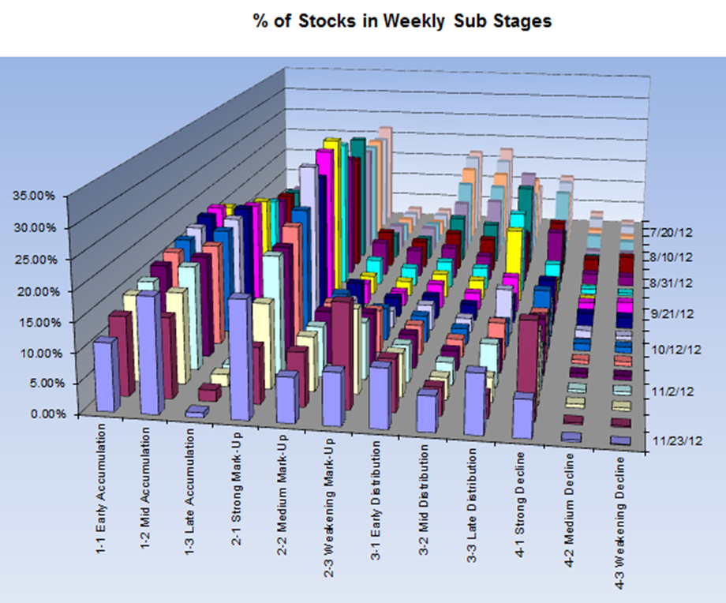
Such a quick sharp recovery in a shortened light-volume trading week may either warn of a bear trap setup (manufactured to kill the bears and short-sellers) or of a “dead cat” bounce manufactured to allow large players to distribute at better prices after their vacation.
The dead-cat bounce scenario is supported by reports that most buy programs last week and especially on Friday were originating mostly from one giant hedge fund (SAC) which seems to be capitulating in a massive short-squeeze. One isolated mega hedge fund doesn’t make the market for long and this bounce needs to see real accumulation follow-through from other large players on any small pullback or consolidation to become reliable.
On the other hand, the bear trap scenario is supported by the weakness in the US dollar and the fact that all markets outside of the US were open for 5 days and many saw weekly gains between 5 and 7% on above average volume. This suggests that true worldwide macroeconomics dynamics are currently at play. Another supportive factor is the abundant QE-induced liquidity and this last week of November will undergo the most aggressive buy operations (liquidity injections) scheduled by the Fed in weeks.
Caution is still recommended on the bullish side as long as the graph of the percent of stocks in weekly Accumulation and Mark-up stages stays below its 5-week average. This indicator tends to catch pretty well the long term cycles of the market and it is currently negating the odds of large gain potentials in the long run.
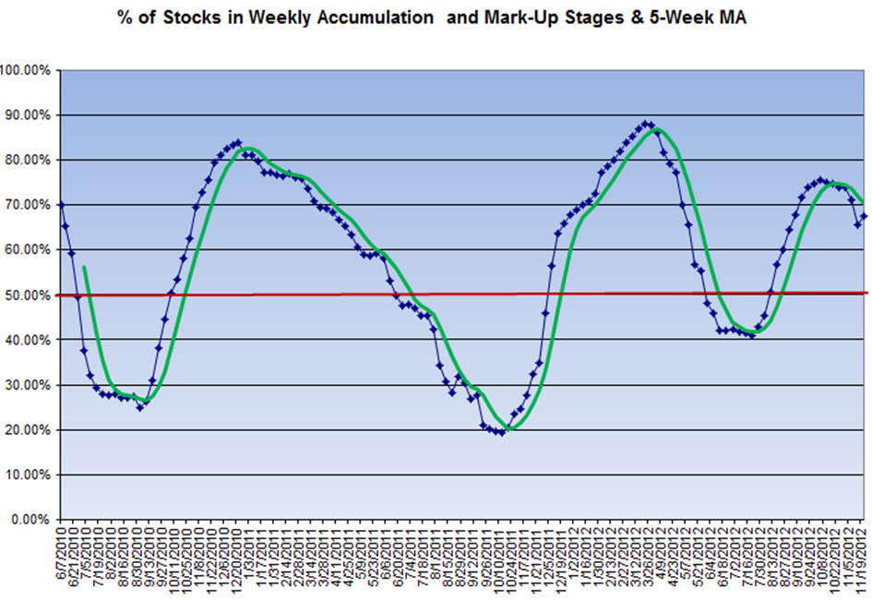
On the daily timeframe, we can observe a steady decrease of the percent of stocks in strong decline but only for a minor shift into medium and weakening decline sub-stages. There are no meaningful increases in accumulation stages yet and this is a pre-requisite for the building of solid bases prior to a sustainable rally. A fall back into strong decline would be rather easy to achieve at this time.
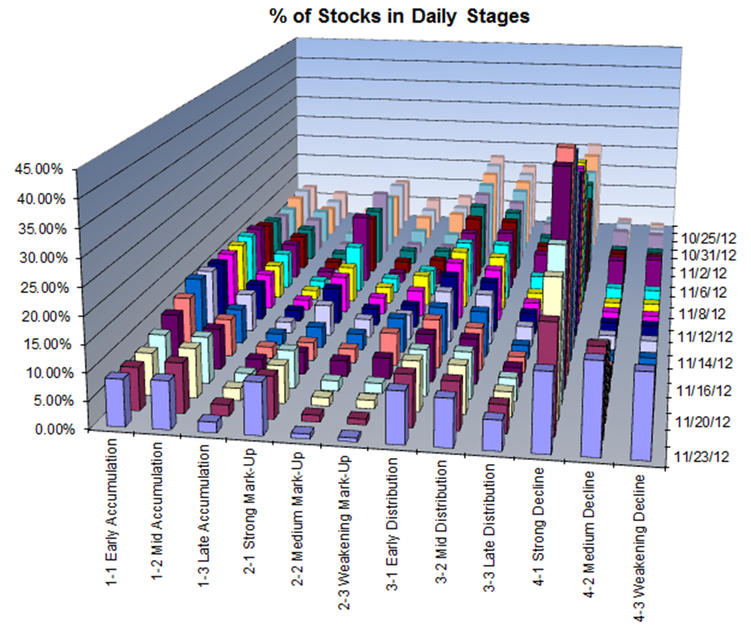

Finally, let’s have a look at risk appetite for small cap stocks which often indicates when a market rally is for real. The IWM correlation score with daily stages is still offering better reward-risks setups on the short side until the indicator can break and hold above its 20-day moving average. We can observe that prior bottoms have witnessed significant short-term choppiness and we are probably entering such a phase if a bottom was made in mid-November.
Billy (www.effectivevolume.com)

