PercentB trendlines may offer insight into the strength of a current trend in GDX (or other instrument), and may help in forecasting where changes of trend will occur. In this paper, I will review an approach that may complement your method for assessing trends in GDX price.
My paper is based on learnings from following the work of Ian Woodward of the High Growth Stock group and experimentation. As noted, this potentially applies to all traded instruments, but for the purposes of this review, we’ll focus on GDX. NOTE: If you are not familiar with Bollinger Percent B, go to the last page for a short overview.
In the following pages, I present an approach that may compliment how you currently use Percent B information. I corresponded with Pascal on this and he suggested that I share this with the forum. If you like this information, let me know and I’ll try to post weekly, or on some recurring basis.
Let me first explain the setup of my screen.
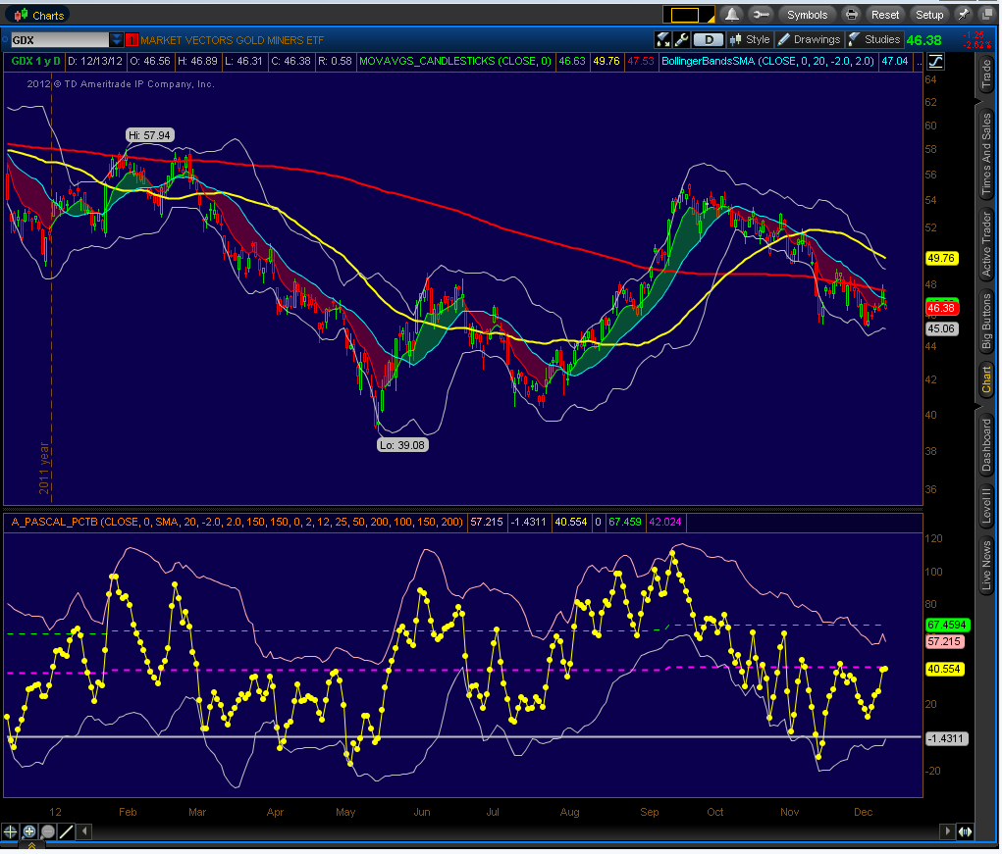 | Top Panel:  - Bollinger Bands – 20 period (white lines)  - Moving Averages:  - 8EMA / 20 SMA – forms the green / red moving average envelope  - 50 SMA – yellow  - 200 SMA – red  Bottom Panel:  - Percent B study wrapped in 20-period Bollinger Bands.  - Yellow line – Percent B value  - Fib Lines for Pct B (see note)  - Green – 61% of PctB High  - Magenta – 38% of PctB High  - White line – PctB value = zero
PERCENT B FIBLINES
Fibs are important, so I figured that I would look for extreme values of PctB and draw some fib lines to see if they acted as support/resistance for PctB. From my observations, it does look like they may be a good reference point. Logically, if you are trending above the 61Fib, you are in an uptrend, and if you are below the 38Fib, you are in a downtrend, but nonetheless, it is interesting to note how Pct B tends to move towards those levels.
For this review, I chose to look for the highest PctB in the last 200 periods and draw my Fibs based on the highest value in that time frame. Why 200 periods? No reason really, just an arbitrary number to make the graph look a little cleaner – it is just a reference point anyway, so this is probably a reasonable setting.
PERCENT B TRENDLINES
This is the crux of it - the occasional spikes presented in a PercentB graph may provide a possible indication to the direction of a stock. Drawing trendlines on these spikes and extending them into the future, often provides an interesting reference when monitoring PctB movements. From my anecdotal observations, I have seen new trends start after these trendlines are decisively crossed. In the screenshots that follow, evaluate how price moved relative to the longer-term and shorter-term trendlines that are drawn. In many cases, these trendlines seem to act as support or resistance. Hindsight is “20/20”, and one could say that I simply fit the trendlines to support the commentary, so I encourage you to apply this approach and see what you find. As I discuss where a trendline is being drawn, pretend that you do not know where the future price will go, and you will then be better able to evaluate if these trendlines are of use to you. If you do not have Percent B on your platform, you may be able to find it at Stockcharts.com, or other online service.
DRAWING THE TRENDLINE
- Look for very high spikes of Percent B (“spike A” and “spike B”), and then after a subsequent decline, look for the next major spike up. Draw a line connecting these two points, and extend it into the future, to the zero line.
- If the next large spike that follows “spike B”fails to exceed the trendline, this often confirms the downtrend.
- If the next large spike decisively crosses the trendline, a new uptrend may be starting. Watch for a whipsaw, and if there is not a major retrace, then a new trend is possibly starting.
The trendline was drawn between the Feb-March spikes of Pct B, which also corresponds closely to the peak and start of the downtrend.  The trendline was extended to the right (i.e., no effort was made to fit the trendline to what happened in the future).  A few things to review:  - The trendline provides support or resistance – note the spring rally – although the trendline is crossed, it is not held, and the rally fails.  - Later, when the line is crossed in August and the trendline holds, the rally is on.  - Note the position of PctB relative to the Fib lines in the downtrend period. | 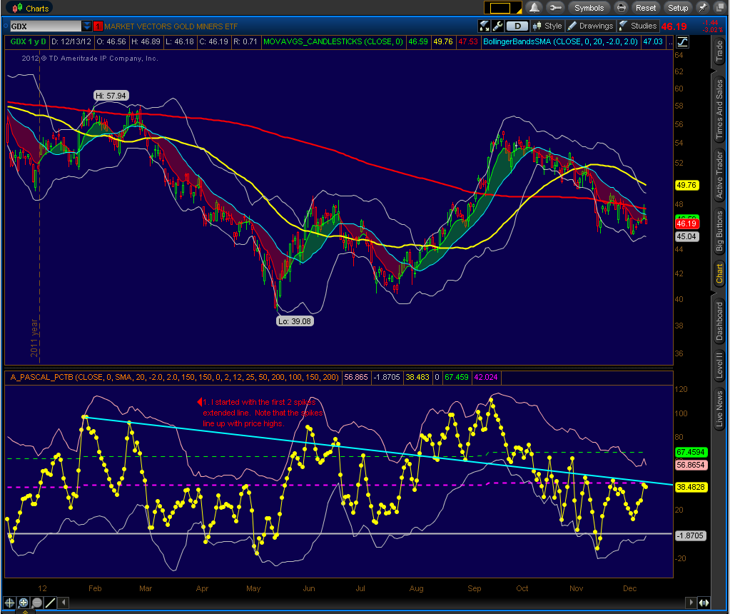
USING THE TRENDLINE TO PREDICT NEW UPTRENDS
These trendlines can be used to predict where a new trend might start, regardless of any other trendline that you may have already drawn.
- Start with the last major percent B spike.
- Look for a Pct B “bounce” usually this occurs within 5-15 period after the peak.
- The weaker the spike, the weaker the forecast, so don’t bother drawing a trendline until you have a substantial bounce (i.e. although spike that get to the 38Fib line are ok, higher spikes are much better to use).
- Draw a trendline across those two spikes and extend it until it crosses the zero line.
- Monitor Percent B relative to this trendline.
March Downtrend:  Note that after PctB starts to drop, it takes a long time to start a bounce, and the bounce spike is very weak – much less than the 38Fib. Don’t waste your time drawing a trendline.  In late March, a positive divergence was developing, and a small pike had developed, so the green line was drawn. As you can see, the move above the trend was weak and then Pct B moved sideways or down for an extended period (under the 38Fib), during which the price decline continued.  The next spike of any significance occurred in early May, and a trendline was drawn. Although not shown, during this extended sideways move of Pct B, the moving averages of Pct B would have been tightening during this period, and primed for a new move. | 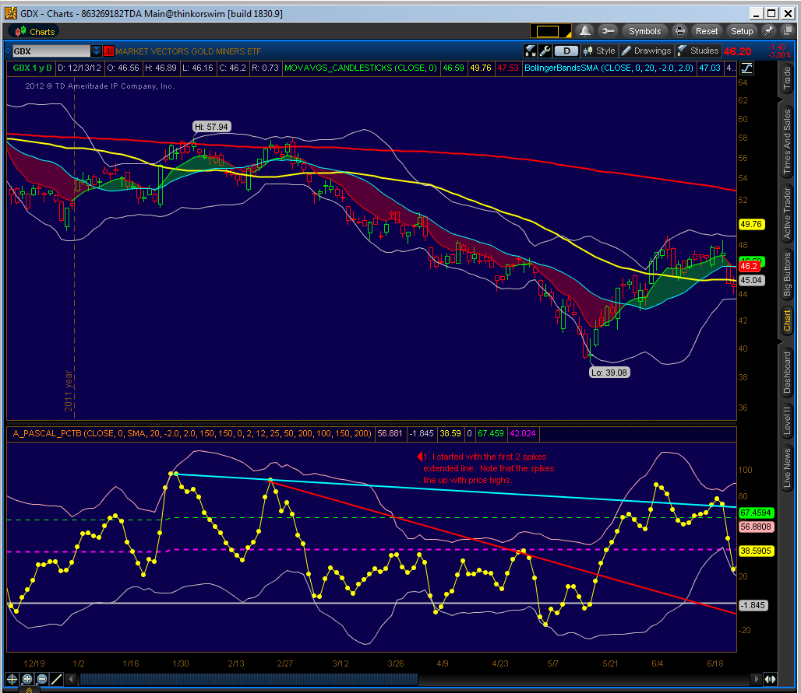
Although you can see that a rebound occurred, pretend that you are back at 5/7 and do not know where price is headed. You have a trendline that is headed towards zero and percent B is starting to get close to the trendline. You also have an encouraging doji candle forming, and the 8EMA is starting to turn up. If you were looking at other indicators such as RSI or Stochastics, you would also see them lining up, so the trendline helps you anticipate where the move might occur.

Now, look at Pct B around 5/6, and you’ll see that it is now less than zero – this is extremely oversold – also note that it is at the lower bollinger band for percent B, so this is a sign to be on the lookout for a rebound, in the next 5-10 periods. Sometimes, there will be a second retest downwards to form a “Bollinger W bottom”, which is a higher low and is bullish.

As mentioned previously, what is also occurring in this type of move is that the percent B moving averages are starting to bunch up at a very low level, and are positioned for a change of trend. Now look back at the screenshot and you’ll see that price is moving upwards as percent B starts to again move upward.

After that move ran its course, I drew another trendline from the two most recent spikes.  Note that at this point the Feb-March trendline is becoming resistance.  The cluster of PctB points in late July is forming a positive divergence, so I would conclude that a new base for PctB has formed.  Note that the 8EMA on the price graph crosses over where PctB crosses the trendline, which coincidentally is on the 38Fib line. With the long-term trendline insight this would be a very positive development.  Stochs, RSI, Candlesticks and other indicators would confirm the new trend that now appears to have a trendline as support. | 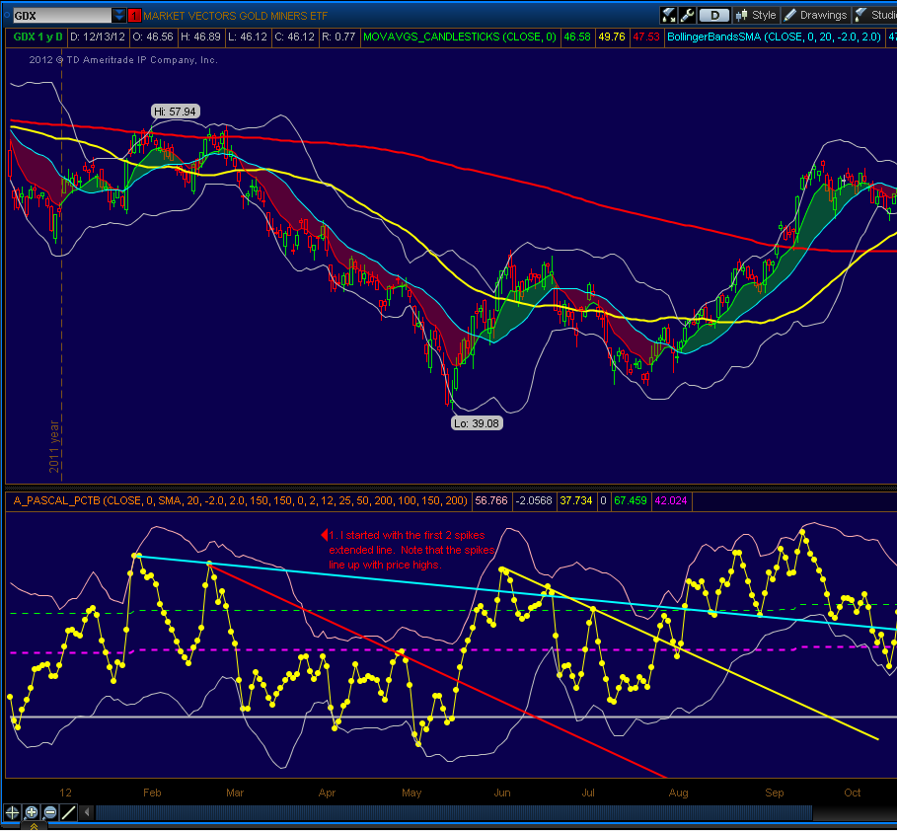

In the next screenshot, which starts in July, you can see that Pct b is weakening, relative to the Feb-March trendline (moving avgs also are a good reference, but I didn’t put them on here to avoid clutter).  When Pct B loses the 61 fib, then you’ve got a downtrend in place  Notice how many of the points are under the 38Fib as the downtrend goes on. | 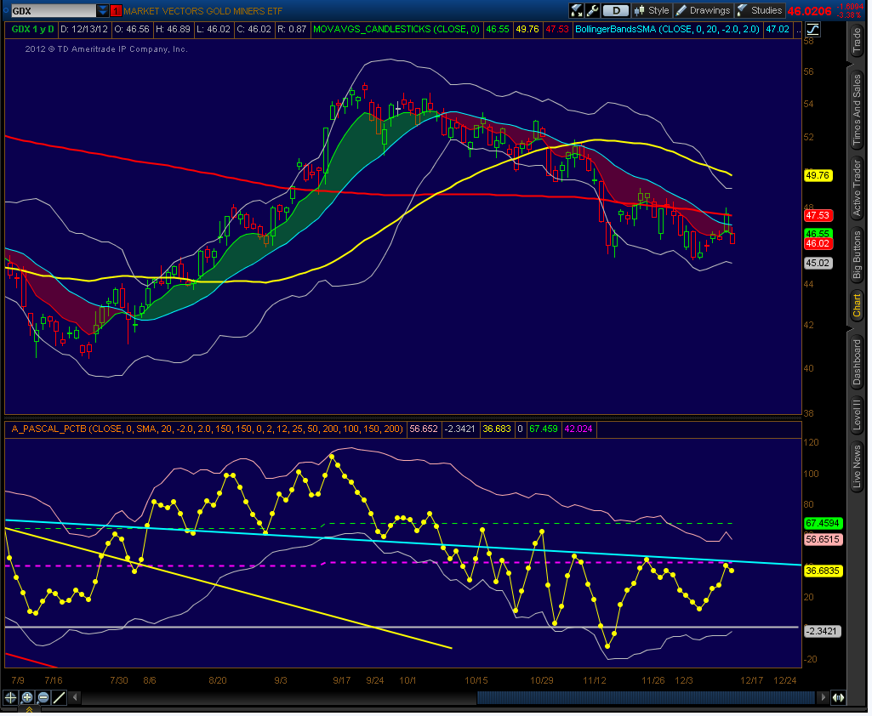

12/13 I had a hunch that GDX would jump yesterday, based on the next trendline, but was distracted and missed the move, but it was nonetheless encouraging to see that trendline method played out.  The trendline itself is not a great one, since there are no major spikes, aside from the 10/29 spike. However, after such a long downtrend, that it might be worth following. The pct B was sitting on the trendline before the jump yesterday. After such a long trend, the reversal is usually good. Too bad, I didn’t show a little intestinal fortitude!  I mentioned that I had added signals based on low PctB to show when buy points might occur (need to align with 8EMA though). It looks like it is retracing a bit today, so if the price stays below the 8EMA, I’d look to that trendline for support. | 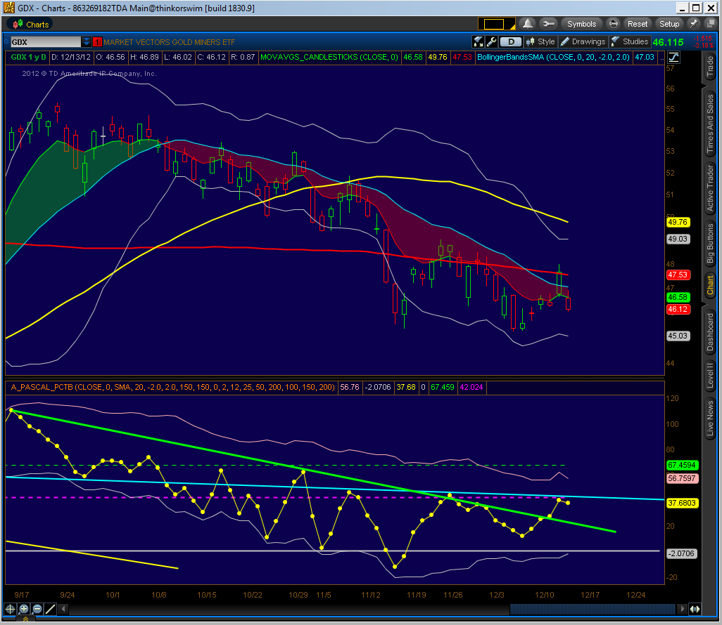

12/13 – part 2
These trendlines are arbitrarily down, so I thought that I would take a second look at the trendline.

I drew a new trendline – yellow line, and this seems to more accurately reflect support and resistance points. What is interesting is that the last touch with the yellow line corresponds to the start of the last upmove.

I wouldn’t be surprised if Pct B drops to that greenline and finds support. Pct B moving averages should be catching up, since Pct B has been below the 38Fib for such a long time, so a new uptrend is likely to start sometime soon, although “we’ll know that in the fullness of time”, to quote Dave Steckler (of ETFroundup.com).

This screenshot is a little cluttered, but I want to provide it to illustrate about moving averages for PctB. I usually have these turned off, to reduce the clutter.  In the screenshot is the 20MA (i.e. the midline of the Bollinger Band for PctB), along with a 100 period MA.  You’ll notice that there is still a gap between these averages, but they are starting to converge, and PercentB seems to have found a base on its 20MA, and the bands seem to be starting to turn up.  In addition, I coded in some alerts that you can see so that I am warned if a possible buy or sell might be emerging. | 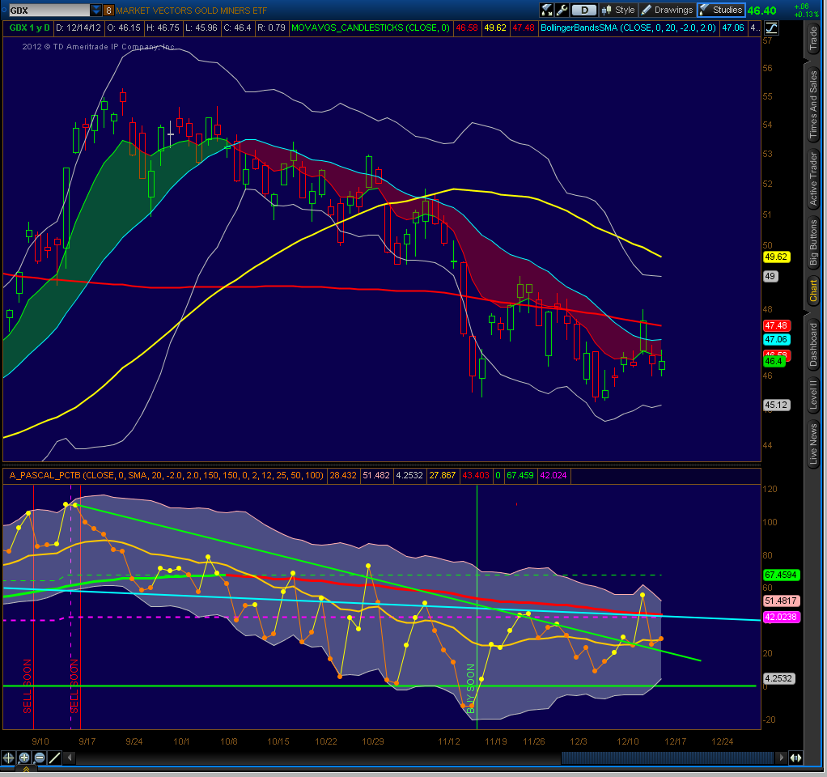

Here is the same chart on a 60 minute view  Note how the 20MA Pct B line started to trend up on the previous Wed-Thursday.  After the recent drop, note that the 20MA and 100MA are now converging, so expect a move soon. | 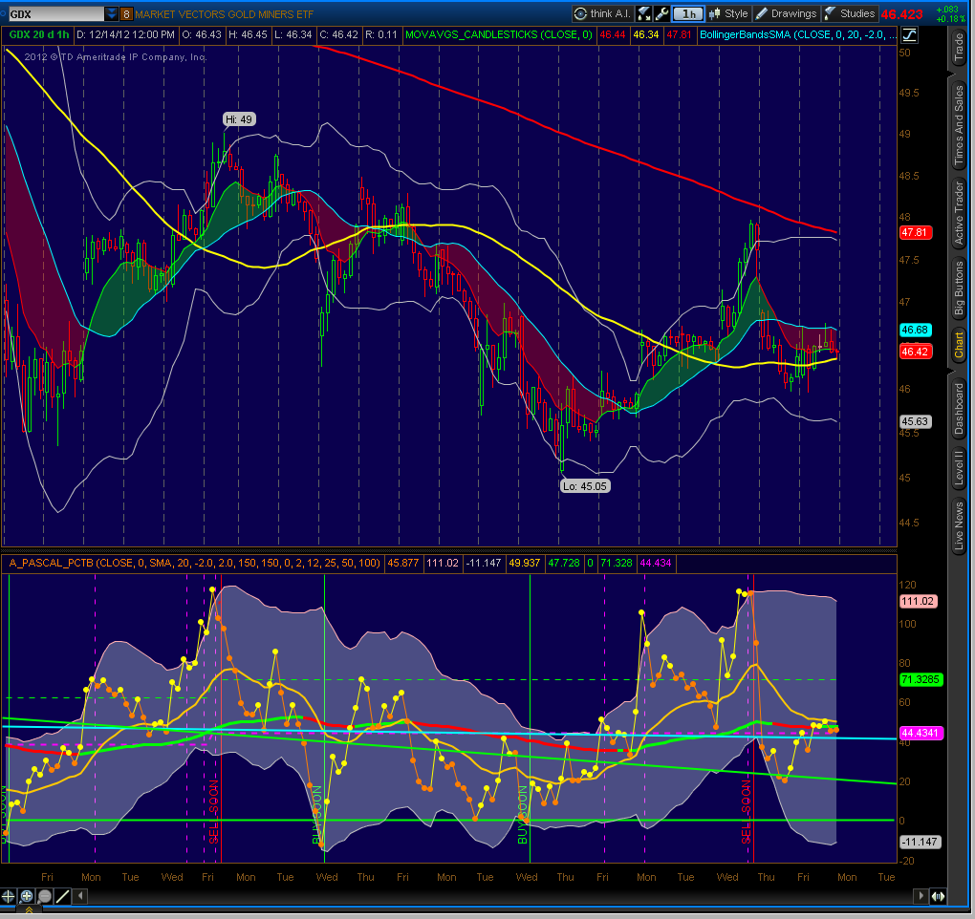

Bollinger Bands (aka “BB”) are based upon applying a normal curve distribution to price movement. A “Normal Curve” is shown on the right - the line in the middle is the average value (“mean”), and on either side are positive and negative “standard deviations”. As you go farther out, these are called “tails”.  From statistics (and Wikipedia), about 68.2% (i.e. 34.1% + 34.1% on the graph)of the values lie within 1 standard deviation of the mean. Similarly, about 95.45% of the values lie within 2 standard deviations of the mean. Nearly all (99.73%) of the values lie within 3 standard deviations of the mean. | NORMAL CURVE (3 Standard Deviations)  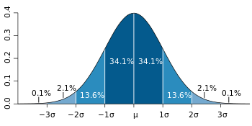
Bollinger Bands apply a normal distribution to price movement. A standard Bollinger Band uses a 20 period simple moving average, and this is shown as the middle line on your chart. The upper BB is two standard deviations above the 20 period moving average price, while the lower BB is two standard deviations below the 20 period moving average price.
- From the statistics provided above, you can look at the price values on your chart, and 95% of them should fall within the Bollinger Bands; if they are outside the bands, then this is an unusual event, and could signify a change of trend, or perhaps extreme strength or weakness.
Percent B is a measure of where price is in relation to the upper and lower bands. %b equals 100 at the upper band, 50 at midline, and 0 at the lower band.
A rule of thumb is that if Percent B is staying above 50 stock price will be going up, since that means that the price is trending higher than the 20 period moving average. Therefore, the higher the overall Pct B trend, the better the chance for good returns.
However - extremes of PctB are important to watch and often foreshadow turning points.
- Extreme highs often signal the end of a trend, for example, Ian Woodward has a phrase “12 Drummers Drumming” which goes into effect after an index high of 120 PctB, which states that a downturn warning is in place for the next 12 or so periods.
- Extreme lows indicate oversold conditions and that a change in trend may be near. However, depending upon the strength of the trend, it may take a while for the moving averages to catch up and provide confirmation.

