WEEKLY MARKET BRIEFING – February 25, 2013
By Billy O’Nair – www.effectivevolume.com
Next week might be the most turbulent one in a long time:
- The USD is on the verge of breaking out major long term resistance;
- It will be an extremely busy week for economic data, especially regarding housing;
- Friday’s sequester deadline will animate the market with nonsense political headlines from both Republicans and Democrats;
- Ben Bernanke will testify before the Senate Committee both Tuesday and Wednesday and any of his words can move the markets at once.
- Fed liquidity will continue to abound with daily buy operations until Thursday when a new POMO schedule will be released.
On the currency front:
The US dollar (UUP) strengthened and gained an average + 1.23% against all major currencies last week, its biggest weekly gain since July of 2012. It is now just shy of 1% from breaking above a major 3-year old resistance downtrend line located at the apex of the triangle formed with the uptrend support line from mid-2011. Such a breakout would certainly signal an important change in the global macroeconomic environment with transitional turbulences in the commodities and equity markets.
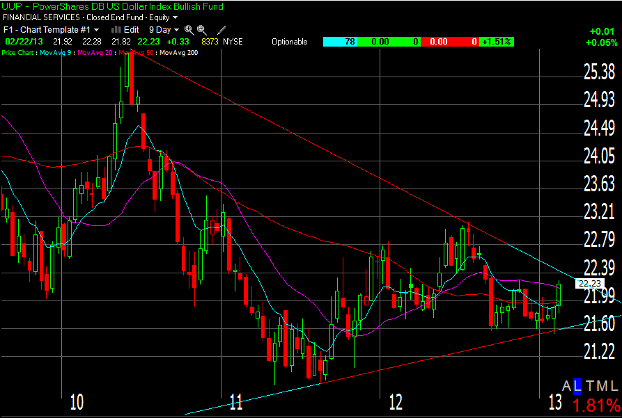

Such breakout anticipation is quite realistic as Moody’s downgrade of the UK after the close on Friday and this weekend’s unclear elections issue in Italy following a big downside revision of growth prospects for the whole euro-zone will certainly pressure the Euro.
In Asia, while China (and its stock market) experiences a slowing economy, the Japanese yen remains in a free-fall fueled by deliberate debasement of the currency by the Bank of Japan. The yen sits now at a 3-year low and this will easily support a stronger dollar. And we know that a stronger dollar correlates inversely with commodity and US equity prices, at least in the short term.
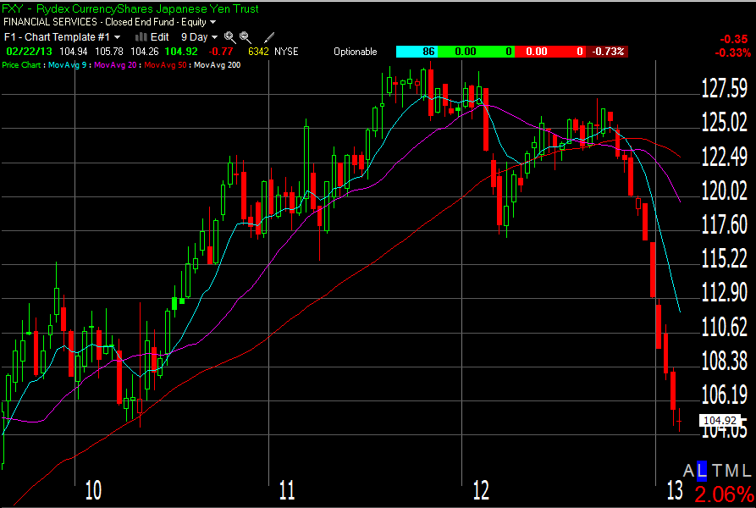

On the economic front:
This week's economic calendar is packed with a long list of usual sensitive data. Because the housing-related sectors were the main drivers of the current rally, I will focus on the market reactions to a wave of housing data beginning to roll in on Tuesday, when Wall Street will have the chance to digest the latest S&P/Case-Shiller 20-city home-price index, the FHFA House Price Index (HPI), and new home sales figures from Uncle Sam. Wednesday's calendar features the MBA mortgage index, and pending home sales. Last week’s housing data disappointed on Wednesday and laid the ground for the sell-off after the Fed minutes’ release. So any new disappointment could easily pave the way to further selloffs.

On the sequester front:
On March 1, $85 billion in spending cuts will kick in if a budget deal between Republicans and Democrats is not reached. These will probably repeat their “last minute agreement” as they did for the debt ceiling and the fiscal cliff deadlines. But with markets addicted to QEternity, whatever the outcome, the market might evaluate it as a “win-win” proposition. If an automatic spending cut strikes in, the unavoidable rise in unemployment could only force the FED to pump even more QE!
However, let’s remember that at the end of March, a government shutdown looms, unless the debt ceiling is raised. For sure, political uncertainty and risk will haunt the minds of market players in the coming weeks. Hedging strategies and mean-reversion tactics are likely to completely change the trending pace and rhythm of the market experienced since mid-November.

On the Money Flow front:
Since its buy signal on November 15, the 20-Day Money Flow took the hardest blows on Wednesday and Thursday last week and it only barely recovered on Friday. Negative divergences with the indices are growing daily and the 20DMF is starting to flirt with a short signal.
We will short if the MF crosses below -0.176% and Cumulative Tick < Average Cumulative Tick. If these conditions are not met, we will turn to cash when OB/OS (Overbought/Oversold ratio) falls below -72.
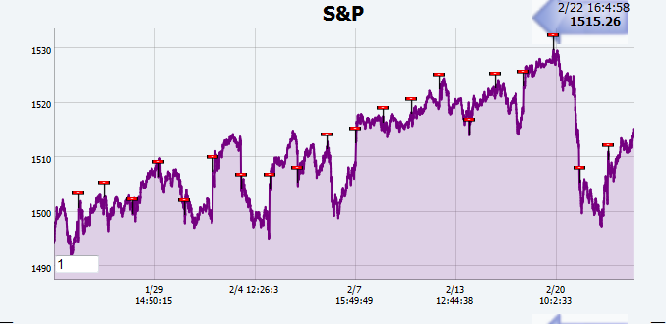
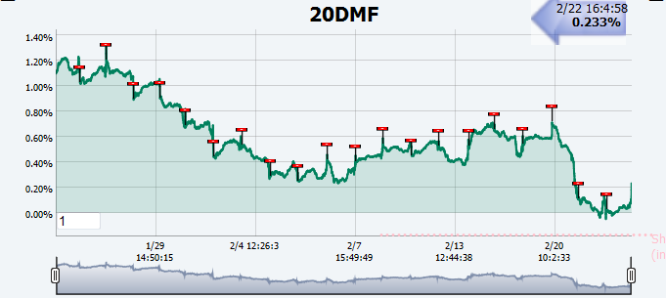
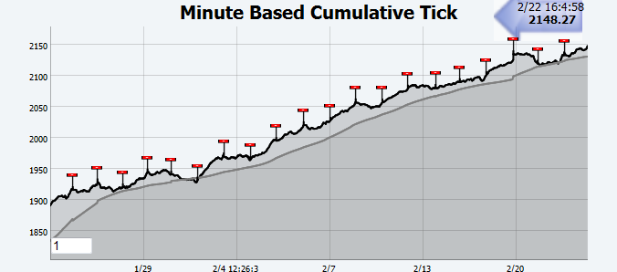
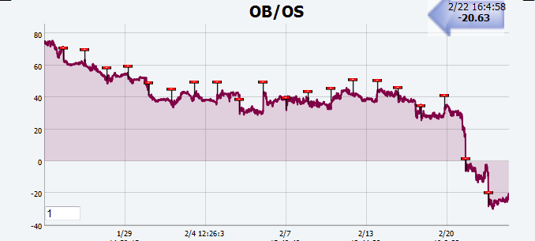

On the Accumulation/Distribution front:
Last week’s sharp fall in the IWM correlation score with IBD’s Acc/Dis ratings confirmed a massive run away from intermediate term risk-taking by institutional investors. This was brewing since the end-of-January cross below the 20 dma and its failed backtest last Tuesday. IBD ratings are a 63-day measure of institutional Acc/Dis and the current momentum reversal favors cash and shorting setups for the next 3 months unless the average is crossed up again. This indicator may be misleading for the very short term and hence, I advise to normally only enter short trades into strength currently near logical areas of resistance. Many indexes and stocks are sitting right below their declining 5-day moving averages. From a risk-reward perspective, this is the place to try new short entries.
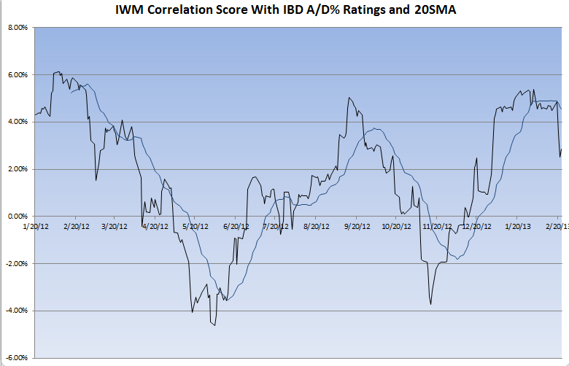
For example, on the 30 min chart below, the 65-period average is equivalent to a dynamic RT 5 dma. I would only enter a new short trade on the first undercut of the previous 30 min candle AFTER the 5dma has been touched or crossed and IF/WHEN the Relative Strength vs. SPY trades under its own declining 5-day average in the lower pane.

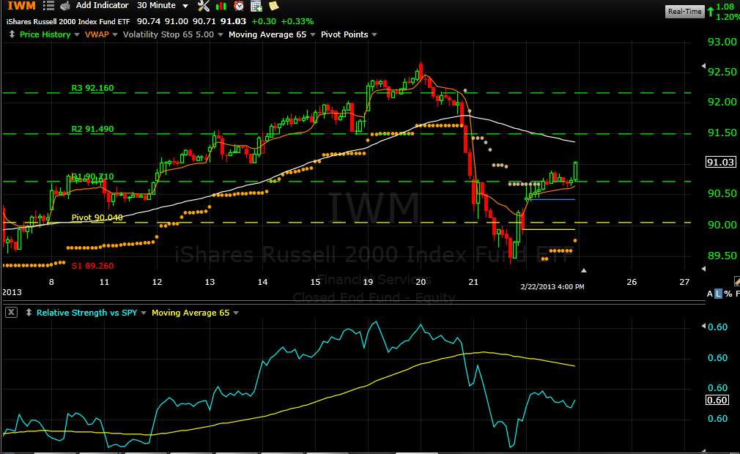

I still believe it is early to become too greedy on the short side before we have more price decline confirmations. If the trade succeeds immediately, I’ll let my profit run and scale out at various supports, but if the trade runs against me after entry, I won’t stay stubborn for long.
When trading indices ETF’s, be aware that near a top, although distribution days are piling up and leading momentum stocks are accelerating their deterioration, there is a significant rotation into high-dividend defensive stocks (Consumer staples, Utilities, Healthcare,…) and this can delay significantly a sharp correction in the ETF’s price. And as long as POMO buy operations reign supreme, never be surprised to witness late intraday strength usually starting to surface around 2:15 PM.
Conclusion:
Observation, wisdom, caution and patience should be our best guides through the coming turbulences!
Have a great week,
Billy

