WEEKLY MARKET BRIEFING – March 4, 2013
By Billy O’Nair – www.effectivevolume.com

As expected, the market shifted gears into turbulence last week for deceptive end results. In the end, the dollar (UUP) was once again higher and is now breaking above its key 3-year downtrend resistance line and triangle while gold (GLD) and most other risk assets were weak. Commodities and Equities were mostly flat for the week.

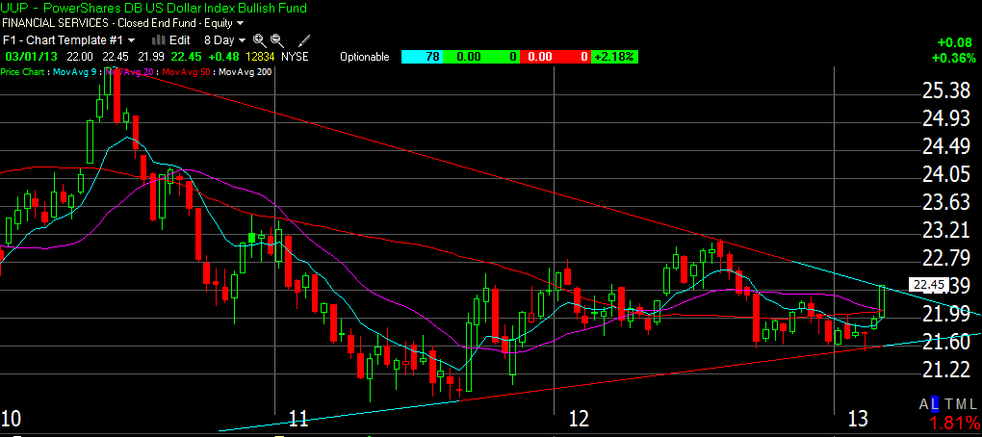

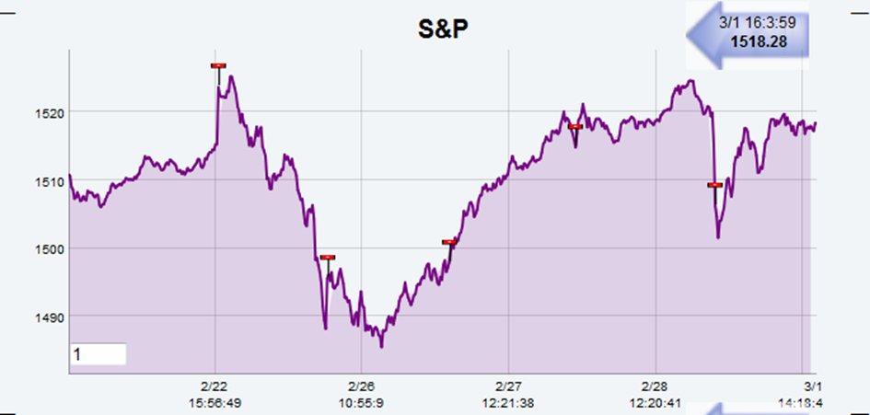

Cumulative TICK shows that Algos have been systematically buying the weakness, but it was the end of the month, and window-dressing markups by funds into March could largely be in play helped by the usual POMO liquidity boosts.
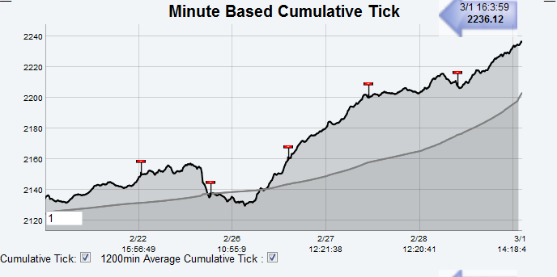
Volume and money flow were once again light and clearly demonstrate that this is more about distribution than accumulation given heavy volume sell days and scarcity of progress among leading stocks. Buy programs may be switched on with light volume just to stop and reverse with heavier activity for better volume-weighted average selling prices. The growing negative divergence with the 20DMF reflects this phenomenon. Our 20DMF model will cover its short position into cash if the 20DMF crosses above the 0.176% level.

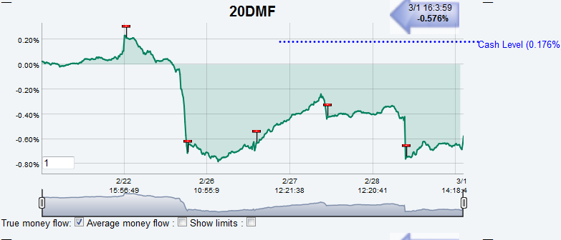

It will go on a buy signal only if the Overbought/Oversold ratio crosses above 30 before the MF crosses over 0.176% and this could happen this week maybe jointly with some IBD type FTD (Follow-through day).
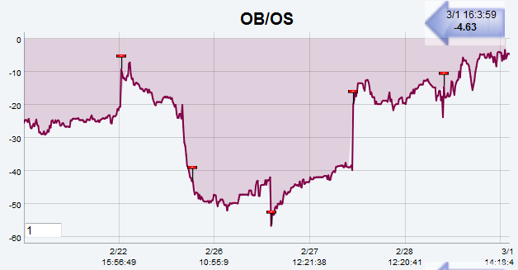
The IWM correlation score with IBD’s Acc/Dis Ratings fell further away from its 20 dma and displays only a pathetic little pop-up. This remains a risk-off environment.

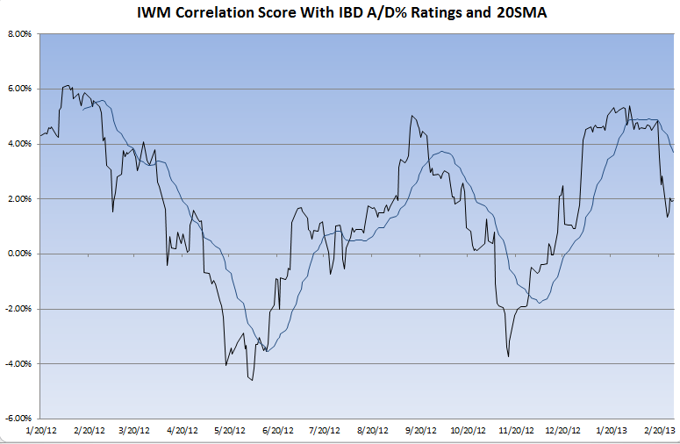

However, with QE the main bullish driver many usually reliable indicators may be overwhelmed by this liquidity. There will be POMO’s each day next week except on jobs report Friday. A negative reaction to the report could hardly be saved by freshly printed money on that day!
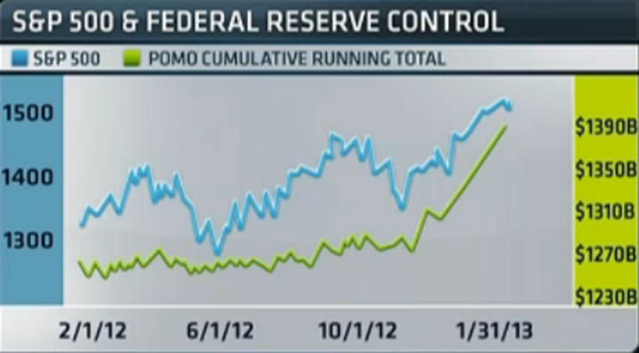
The financial sector could be impacted by the release of government stress tests on March 7 and the approval or disapproval of capitalization plans submitted by individual banks on March 14. Analysts are unanimous about the fact that it will be a “no problem” event. But we will be on the lookout for any bad surprise here after seeing the incredible underperformance of the “defensive” financial sector these last few weeks and days. We haven’t seen such a negative Effective Volume and Large players/Small players imbalance for XLF since 2008! This could be preceding a sharp price decline as funds and institutional investors are clearly distributing the sector more than any other one in this consolidation phase.
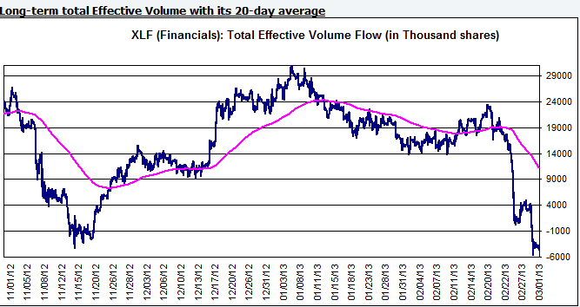
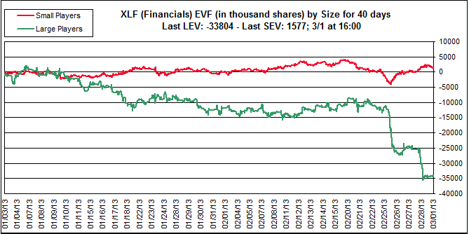

The market is getting erratic and in a typical choppy “reversion to the mean” consolidation phase. I believe that the market will start to react more to technical levels from this point on and chances are high that we will start to see more and more divergences on any rallies from here on out. As a trend follower, you can't bet on any price trend here. You need to wait for upside or downside follow through. It is perfectly fine to sit on your hands and let everyone else fight it out while the market is bouncing back and forth.
If you can’t resist the urge of being an active trader, be aware that, next week, the market moves are likely to stay fast and punishing if you miss them. Be really proactive by booking any quick profits and preserve your capital. Just take what you earn, and move along to the next trade.
You need to trade much tighter (taking quicker profits and losses and using smaller positions) and be content. There is a need to wait for more clarity before doing anything larger in size or directionally. That's what you do during choppy consolidations.
Billy

