Use of underlying Market conditions as a means to estimate the probability of an IBD Follow-Through Day Success

A study was undertaken to determine if there were some predictors of a market rally success that were coincident with a follow-through day (FTD). For this study a definition of a successful was predetermined. Short rallies rarely provide an opportunity to make significant money in the market. The authors trading styles and past successes and failures following CANSLIM rules prescribed the following definition of a successful rally:
- NASDAQ price moves up and closes above the close of the FTD at least 9 or 10%
- This high close date is at least 5 to 6 weeks later than the FTD

Rallies of this magnitude and duration allow sufficient time to fill out a portfolio and take normal gains as the rally proceeds. Shorter rallies or weaker rallies often provide limited opportunities to make profit or lead to portfolio losses. Of course we hope for longer and stronger rallies.

78 FTDs have been recorded beginning with the first rally of 12/14/1994. This is the dataset used in the analysis. These FTDs were segregated into underlying market conditions of bull and bear markets. In general most FTDs fail that occur in a bear market and about half work in a bull market.

Various market parameters were selected at the outset to determine if they offered any insight as to whether a FTD would produce a successful rally. Three parameters were discovered that offered some insight. The obvious parameter, magnitude of the volume on the day of the FTD was found to offer no advantage. The three surviving parameters were: a FTD-proximate Coppock Curve buy signal, a FTD-proximate Eureka signal and a FTD-coincident percent of the IBD 6000 index stocks showing an E Accumulation/Distribution rating. Most of these terms are not in general use in the investing community and an effort to describe them is undertaken in three appendixes.

In general a Coppock Curve buy signal offers the greatest predictive strength. The Coppock Curve based on Index monthly close data offers insight to when a cyclical bear market is ending and a new cyclical bull cycle is beginning. A Coppock Curve generated using weekly close prices offers the strongest and timelier evidence of the beginning of a new market rally whether it is a rally after a short correction or the beginning of a new major cycle. In general with bull market conditions a rally that begins with a FTD succeeds about 45% of the time if you use the definitions of a successful rally as described in the first paragraph above. A bull market rally that is proximate to a Coppock buy signal however has succeeded 79% of the time. This is believed to be a significant indication prior to the rally start that a rally is likely to produce profits. The proximity for this Coppock buy signal in relation to the FTD date is plus or minus 4 weeks. Rallies where a Coppock buy signal occurred outside of +/- 4 weeks from the FTD date failed 73% of the time in bull markets and 95% of the time in bear markets. The buy point is described Index I.

The next most predictive indication at the outset of a rally was found to come from the Investor’s Business Daily IBD6000 index. This index contains all of the stocks in the IBD database that trade above $5. The index is analyzed by IBD to count the number of stocks in the index that are showing the various levels of Accumulation or Distribution. IBD assigns an Accumulation/Distribution rating to each stock in the database from A (strong accumulation) to E (strong distribution). It was discovered that the measure of stocks showing strong distribution (E rating) on the day of the FTD was most predictive. A low percent of stocks showing strong distribution indicates to the authors that investors are bullish or complacent in their market views. On the other hand a large percent of stocks showing strong distribution may indicate that institutions have been selling and that relatively larger amount of money is sitting on the sidelines. It is viewed that money on the sidelines is important to the success of a new rally as that money is put to work. The following results were found in the dataset: In a bull market 79% of rallies failed when the %E was outside of a prescriptive range. When inside the prescriptive range only 24% of rallies failed. The bull market prescriptive range was determined to be %E>7.4% and %E<16%. Bear market statistics were as follows: Failure rate with %E<7.4% was that 100% of all cases failed to produce a successful rally. There were only 9 bear market rallies in the dataset with %E<7.4%, a small number of cases. It was found that in bear markets a rally that begins with %E higher than 16% should not be ignored as historically two of the largest bear market rallies started with high %E values although 70% (7 of 10) produced failed rallies.

The last parameter offering some insight into a possible successful rally is the proximate existence of strong market internal buying as shown by the Eureka indicator. Proximity was determined to be +/- 10 trading days from the date of the FTD. A bull market rally beginning with a FTD that shows at least one proximate Eureka succeeded 52% of the time. The contra indication is that without this sign of strong market internals was that 61% of bull market rallies failed. In bear markets no rallies succeeded without a Eureka in proximity. There were 15 cases of rallies in bear markets without a Eureka with this 100% failure rate.

A limited analysis of coincidence of indications was undertaken. For example in bull markets a rally that begins with a FTD that has a Coppock buy signal and a Eureka succeeded 88% of the time. In bear markets this figure reduced to 57% successful rallies.

Appendix I Coppock Curve

The following Wikipedia article defines the Coppock curve:
http://en.wikipedia.org/wiki/Coppock_curve

This is another article about the calculation:
http://www.safehaven.com/article/1766/how-to-calculate-the-coppock-curve

The image below from www.freestockcharts.com shows the NASDAQ Coppock Curve as the bottom plot. This particular curve is using weekly data and parameter settings of: Short ROC period of 11, Long ROC period of 14 and WMA period of 10. These settings are good for both weekly and monthly intervals. Marked on the curve are white arrows showing the last seven buy signals, which occur any time the curve is in negative values and turns upward.

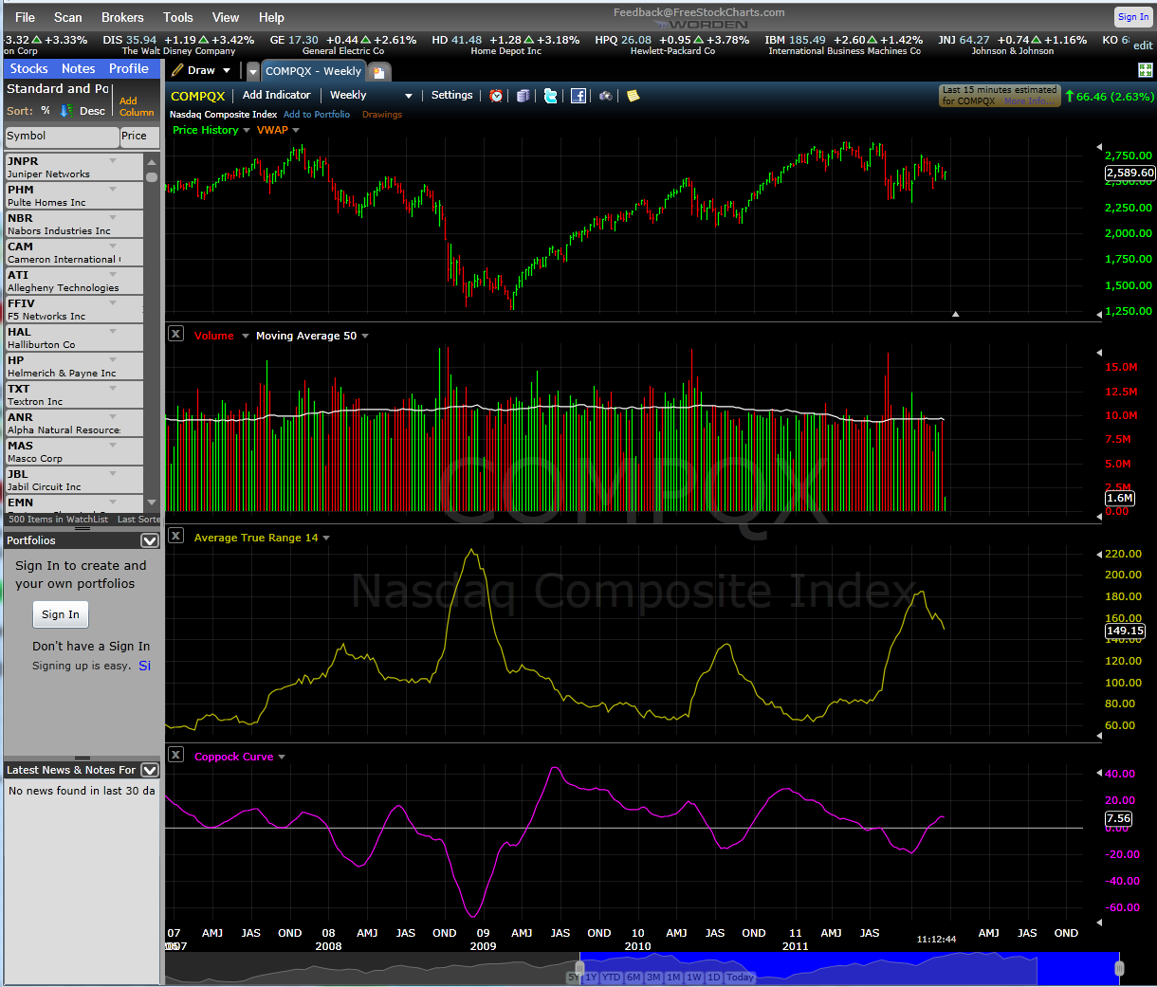
On a monthly time scale over 20 years there have been five buy points: February 1995, November 2001, November 2002, March 2003 and April 2009.
Appendix II IBD 6000 Percent E

The IBD 6000 index has been published by Investor’s Business Daily since 1994. It appears as an inset to the NASDAQ chart on the General Markets page in each IBD issue. This is shown in the pasted chart below with the index highlighted with a gold colored box. The percent of stocks with an E Accumulation/Distribution rating is calculated by dividing the E value by the sum of the A, B, C, D and E values. For convenience this fraction is multiplied by 100 to turn it into a percentage value. I leave it as an exercise for the reader to compute a %E value of 7.3% from the data in the 12-20-2011 IBD issue below.

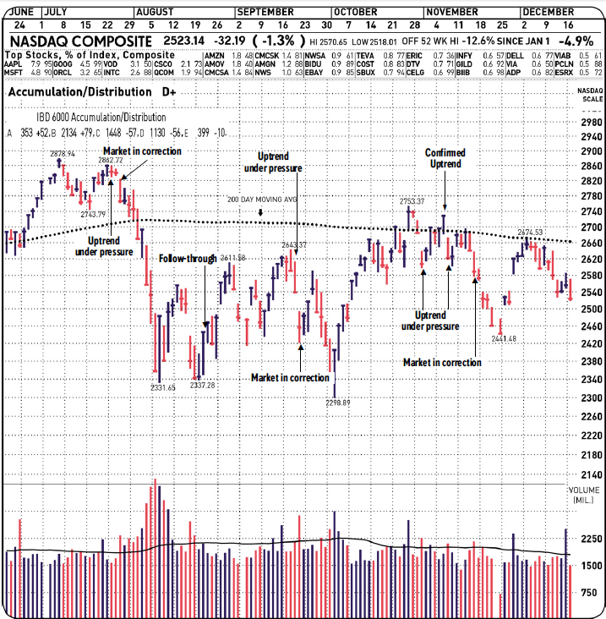
Appendix III Eureka

The Eureka is an indication of strong market internal strength. The Eureka was developed by Ian Woodward who resides in Palos Verdes, CA. Essentially the Eureka is a mathematical construct using NYSE advance/decline issues and advancing volume/declining volume data published by various sources such as The Wall Street Journal. Richard Arms developed an indicator called the Arms Index or TRIN (Trend Indicator) using the same terms. The TRIN is available on many financial reporting sources usually with a symbol such as $TRIN or ^TRIN. The calculation for TRIN is as follows:

TRIN = (Advancing Issues/Declining Issues)/(Advancing Volume/Declining Volume)

In general a TRIN < 1.0 is bullish and bearish for TRIN > 1.0

Ian Woodward developed and back tested an approach that looked at the TRIN and the numerator and denominator of the TRIN separately and came up with the following relationships.

A Eureka occurs on any day that meets the following criteria simultaneously:
Advancing Issues/Declining Issues >= 2.98
Advancing Volume/Declining Volume >= 5.4
TRIN <= 0.63

These days can be rare but the implications are that institutional activity can only produce them. Having a FTD in the proximity of the date of one or more Eureka’s improves the odds that institutional sponsorship of the rally is there and the rally has more chances to succeed.

