IWM CORRELATION SCORE WITH IBD’s ACCUMULTION/DISTRIBUTION % RATINGS
Billy O’Nair – www.effectivevolume.com – February 28, 2013

- Some insights on how to interpret the indicator.

IWM is the liquid small caps stocks ETF and as such tends to be the most volatile and risk-sensitive instrument among (unleveraged) broad indexes ETFs. It allows institutional investors to conveniently and easily increase or decrease their exposure in a basket of 2,000 mostly illiquid small stocks that they would normally avoid trading individually except for the few ones on their watchlists.
Based on historical observation, one can confidently conclude that small caps tend to outperform large caps in early institutional accumulation stages and underperform in early institutional distribution stages. Therefore, on its own, IWM is some kind of a leading indicator of institutional “risk-on” and “risk-off” appetite for the general market.
When using IWM price’s correlation with IBD’s Acc/Dis ratings, we add the important volume and institutional timeframe (3 months) dimensions to the picture. IBD’s ratings are proprietary, but have proved incredibly helpful and reliable for decades to thousands of CANSLIM investors for gauging correctly the institutional activity in individual stocks. This is why and how I came to the idea of combining the aggregate Accumulation/Distribution ratings for all stocks of institutional quality with the leading IWM ETF and developed the IWM correlation score.
After some preliminary backtestings, it soon became clear that crossings, support and resistance at an arbitrary 20-day moving average of the score was indicative of important points of inflection for transitions back and forth between “risk-on” and “risk-off” institutional market environments. 20 days represent about one-third of the IBD ratings timeframe and this tends to confirm the leading nature of small cap stocks over the rest of the pack.
I must stress that this is not a precise general market timing indicator and that it is best used for favoring long or short optimal setups in small cap stocks only and especially with the IWM instrument. More often than not, and during topping or basing processes, institutions will unload their small caps exposure but increase their large caps exposure in a mild risk-off strategy. The uptrend often resumes without a deep general market correction. Therefore, one should be extra selective in picking only optimal setups with proven excellent risk-reward ratios.
For CANSLIM investors, this indicator is a good “small caps” supplement to the Big Picture’s market direction or to the Market School’s Market Exposure Model. For Effective Volume traders, it is highlighting what’s happening in the small caps area where EV Money Flow cannot be tracked due to lack of minute-by-minute liquidity.

- METHODOLOGY

- Daily Data Collection from Marketsmith:
I only screen for stocks with both a composite rating and an Acc/Dis rating. This adds up currently to about 4770 stocks/day. Most of the Misc. Sector (ETFs etc.) and the stocks without an institutional profile will therefore be discarded. My available database starts from June 27, 2008.

- Percentages in each rating category:
I currently only use the percent of Stocks in each broad A,B,C,D and E Acc/Dis ratings but plan to switch soon to the percent in each subcategory (A+, A, A-,B+, etc.) for more precision and reliability.

- % Acc/Dis Rating Correlation with IWM:
I regularly re-compute the correlation coefficient of each Acc/Dis rating percent with IWM’s closing price from June 27, 2008 to date. The longer the period grows over time, the more stable and reliable the coefficients become. The last correlation coefficients were computed at the close of February 15, 2013 and were as follows:
A rating: 0.136688076
B rating: 0.102064708
C rating: -0.098678333
D rating: -0.086839627
E rating: -0.13559519
Notice the surprising discovery that % of C ratings correlate more negatively with IWM than D ratings!

- Final indicator – IWM correlation score with IBD’s Acc/Dis ratings
This is simply the correlation-weighted summation of the 5 ratings. Today’s example would be:
(0.136688076*13.92%) + (0.102064708*43.12%) – (0.098678333*21.26%) – (0.086839627*16.25%) – (0.13559519*5.46%) = 2.05%
For your information, I attach my Excel files ACCDISTRIB.xlsx and IBDCORR.xlsx in which I perform these routines.

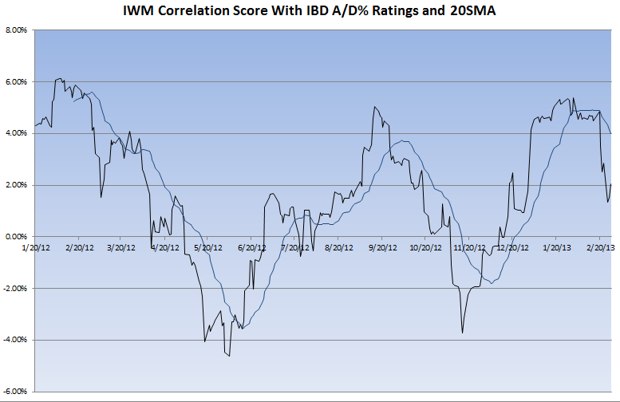
END

