Market Observations: 12/2/2012

Summary: Major US markets remain neutral on weekly and daily timeframes. The oversold condition during mid-November attracted buyers into month-end, and intraday weakness was aggressively bought. The neutral condition suggests to this participant that a juncture is quickly approaching; a new strong uptrend may emerge, or the bounce will soon be exhausted.

Market Stages: Weekly 11/30/2012

SPY | Current Weekly Stage is 3-1 (Early Distribution); Current weekly stage for 1 week(s) | Bullish Turning to Neutral
DIA | Current Weekly Stage is 3-1 (Early Distribution); Current weekly stage for 1 week(s) | Bullish Turning to Neutral
QQQ | Current Weekly Stage is 3-1 (Early Distribution); Current weekly stage for 1 week(s) | Bullish Turning to Neutral
IWM | Current Weekly Stage is 3-1 (Early Distribution); Current weekly stage for 1 week(s) | Bullish Turning to Neutral

Market Stages: Daily 11/30/2012

SPY | Current Stage is 1-1 (Early Accumulation) Has been in current stage for 1 day(s) | Bearish turning to neutral
DIA | Current Stage is 1-1 (Early Accumulation) Has been in current stage for 1 day(s) | Bearish turning to neutral
QQQ | Current Stage is 1-1 (Early Accumulation) Has been in current stage for 2 day(s) | Bearish turning to neutral
IWM | Current Stage is 1-1 (Early Accumulation) Has been in current stage for 1 day(s) | Bearish turning to neutral

Stage Scans: 12/2/12

Results revealed from the stage scans are markedly different than just a couple weeks ago. Weekly strong mark-up stocks nearly tripled since 11/21, while scan 1 results doubled. Something to consider is whether the market becomes a victim of its own strength, and whether such rapid expansion of strong mark-ups results in a temporary pause, at least. A dramatic increase in weekly strong decline stocks occurred just before the 11/21 bottom, and the dramatic reversal in the opposite direction may result in something of a similar nature occurring.

11/30/2012
Weekly Strong Mark-up + Daily Late Accumulation-Strong Mark-up | 258 results
Weekly Strong Mark-up | 671 results
Weekly Strong Decline | 116 results

10/14/2011
Weekly Strong Mark-up + Daily Late Accumulation-Strong Mark-up | 54 results
Weekly Strong Mark-up | 101 results
Weekly Strong Decline | 368 results

In addition to the 11/30/12 scans, I provide the same scans from 10/14/11. The common thread is that both scans were performed 9-days following a low of some significance. One sees that there was much more damage in 2011 than recently. The swift rebound is really quite dramatic. Indeed, reviewing these two periods demonstrates how much milder November’s correction was compared to last year; however, all US markets were in strong decline phases in late 2011, which suggested that more time was needed to put together the base for the uptrend that emerged in the months ahead. Current results suggest that US markets experienced a deep pullback within an aging bull market.

Leader’s List: KORS

If the uptrend persists, then Pascal’s leader’s list highlights some interesting candidates to lead the market higher. KORS reversed to close near the day’s high a couple weeks ago, and follow-through buying is being accompanied by an emergence of large player interest.

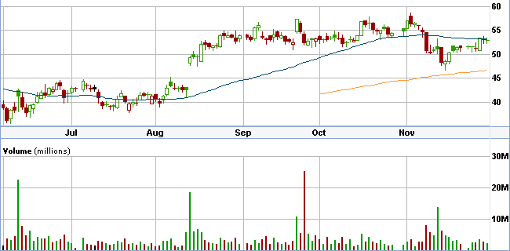

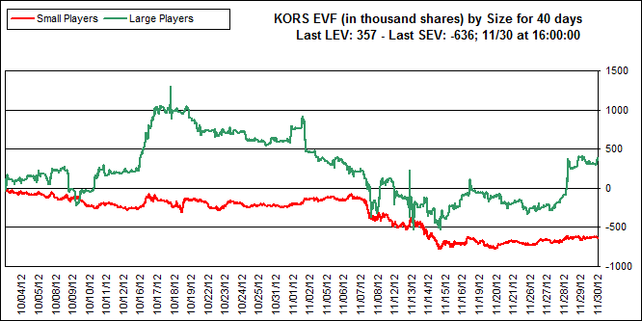

Current Weekly Stage is 1-3 (Late Accumulation); Current stage for 11 week(s) | Neutral on watch for potential breakout to bullish
Current Daily Stage is 3-1 (Late Distribution); Current daily stage for 11 days(s) | Neutral on watch for potential breakdown to bearish

If the market remains constructive on the long side, then KORS may easily resume a leadership position. KORS is also at the neutral boundary of value, which suggests that room exists for price to move higher. The stage structure shows a neutral to bullish long-term bias.

Emerging Markets: TUR & INP

Last week’s report highlighted Turkey as a market worth watching. One sees that after a spike in LEV and brief retrenchment, large players remain supportive.

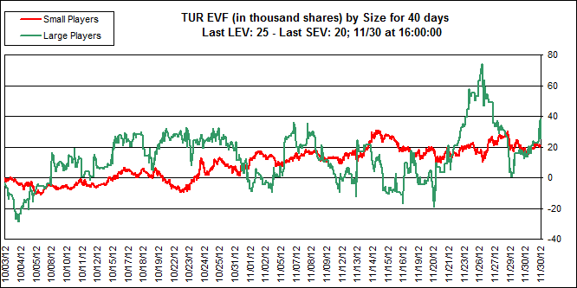

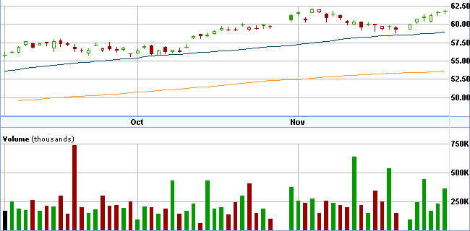

In addition to Turkey, there are two other emerging markets that show underlying strength, while not being overly extended long-term: India and Peru. Numerous emerging markets wallowed in price since early 2011, being decimated while US markets moved higher despite various setbacks – India was one of those markets. Today, India, as represented by the INP or PIN funds, may be entering the early stages of a new Stage 2 uptrend. Second, Peru stocks have essentially gone sideways for the duration of the past two months, while LEV continues increasing. See charts on following page: (INP, INP EV, EPU, and EPU EV)

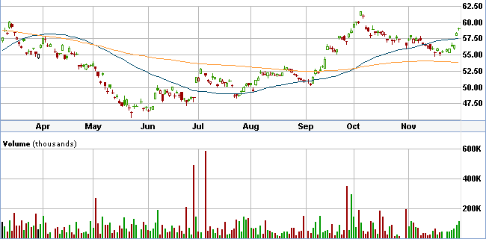

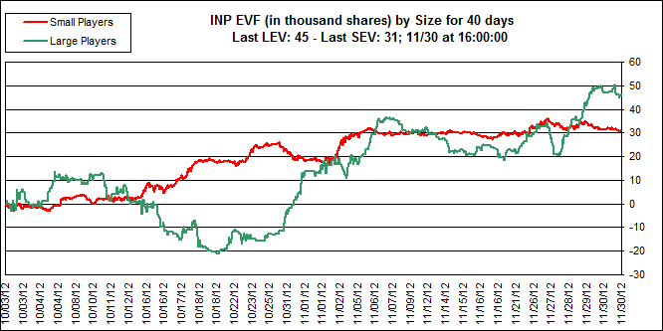

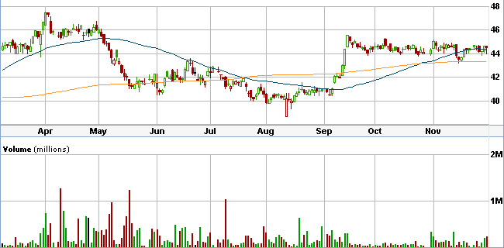

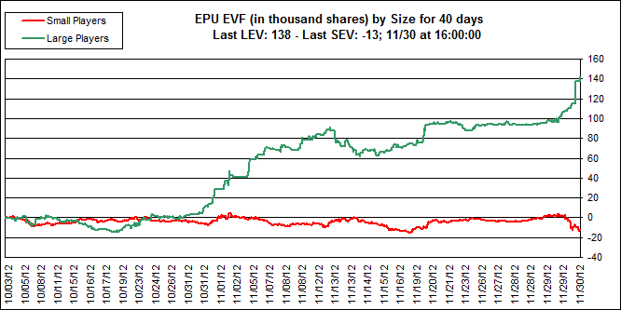

Copper & Gold Comments:

The previous report noted gold’s attempt to move higher, which it did on lighter holiday volume. Those gains were subsequently given back, tempering expectations for another strong move higher and negating my analysis. Interestingly enough, though, both copper futures and heavyweight producer Freeport McMoran have been attracting money in recent days. (Copper, FCX EV, FCX Chart w/200 and 50-day MA)

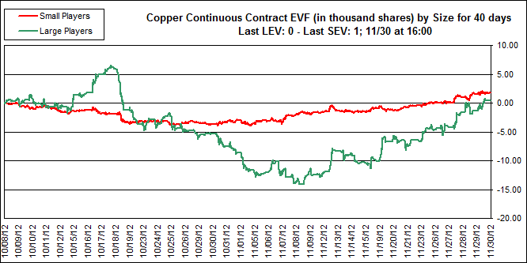

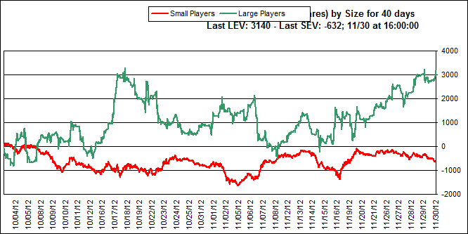

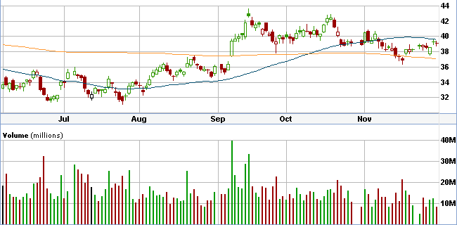

Given perceptions regarding global growth and a possible recession, are inflation expectations finding their way into some basic materials like copper? Does Freeport’s low debt and 3%+ yield attract value buyers at these levels? Is price action in places like Peru and India suggestive of pockets of global strength? These are just some general questions worth pondering and may open avenues of further inquiry.

Natural Gas & Coal Follow-up:

Natural gas experienced a swift sell-off last week and was unable to carry recent momentum – a choppy range above the now flat 200-day moving average seems likely. Still, given the long bear market Natural Gas experienced, recent technical improvements, and a renewed emphasis on energy alternatives, the space bears worth watching.

In spite of natural gas declining, coal stocks continued attracting money. Lower gas prices in recent years hurt many coal companies competitiveness as natural gas emerged a cheaper alternative for various utility companies.

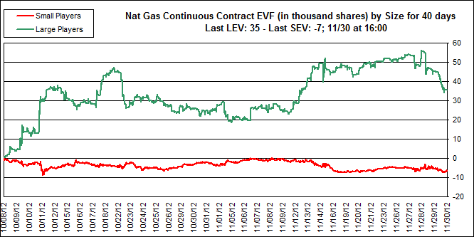

Meanwhile, various coal stocks attract money after rather deep sell-offs following the 2012 election results. A couple examples below . . .

BTU: Peabody Energy
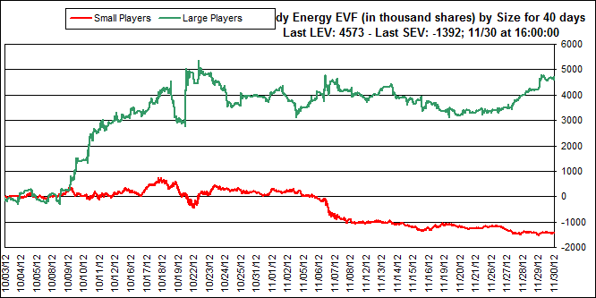

BTU: Peabody Energy 6 Month Chart w/200 and 50 day MA’s
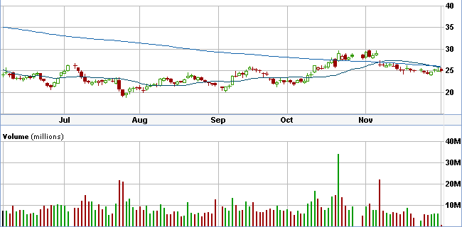
ACI: Arch Coal
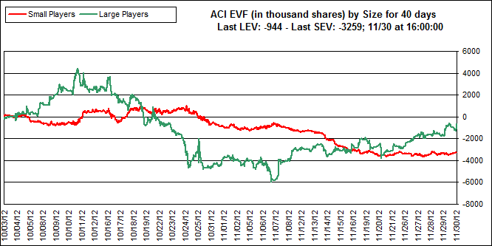
ACI: Arch Coal 9 month chart w/200 and 50 day MA’s
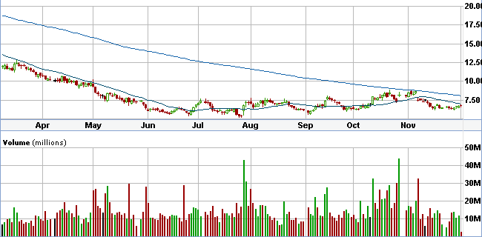

Buying energy, metals, or their related equities on breakouts is often dicey, owing to their uncanny ability for quick retracements in price. On the other hand oversold conditions that attract large players may provide good risk reward trades of varying duration.

Conclusion:

Markets bounced vigorously following the oversold conditions on Friday 11/16, and Pascal’s EV tools signaled a prudent long stance. The week prior to Thanksgiving was aptly described by Billy - “a brief sudden spike in weakening mark-up and strong decline stages.” A quick recovery ensued, which leaves the market at a juncture – will strength beget strength during this seasonally strong period, or will the market encounter more serious pressure in the next couple weeks?

A review of the weekly stage scans indicates vastly different conditions between this year’s November sell-off and last year’s “baby bear” market. Comparing the weekly stage scans 9 days out from each respective low (October 4th & November 16th) reveals a lack of volatility and severity during November, which suggests to this participant that November’s sell-off can be characterized as a pullback within an aging bull market. Conversely, the volatility and fear during October 2011 caused a “reset” in the stage count, which permitted the development of the uptrend that emerged during early 2012. I find it difficult to assess how much “gas in the tank” remains for further upside, though one certainly should not discount the possibility of new highs. Provided below is an excerpt from a Stan Weinstein interview on November 9th, which offers further insight to current market conditions:

The market is Stage 3 topping . . . a lot of individual stocks are in their own private bear markets. And the ones that were clearly bearish were the glamour stocks. That was the canary in the mine. . . Even though blue chips averages made new bull market highs in September, my glamour average topped out all the way back in late March, and the glamours usually lead on both the up and the downside. . . Then there are other things that have already been killed. Some secondary stocks, I’m not telling you what I’m buying, but they don’t look so bad, they’ve already been killed and a lot of them are making early stage 1 bases. So we shouldn’t talk just monolithically . . . Know in general, even though stocks have been hit hard, and are oversold and will have short term bounces, in general, to use analogies, stocks like AAPL, like LNKD, those kind of issues I think are the most vulnerable.

(Courtesy of: http://www.financialsense.com/financial-sense-newshour/big-picture/2012/11/10/01/stan-weinstein/markets-lower-next-3-6-months)

Behind the headlines, interesting things are happening in some markets. India, Peru, and Turkey display various degrees of large player buying amidst technical strength. Copper attracts money while gold languishes. Coal stocks appear to be forming stage 1 bases while attracting money, too. Various soft commodities like Coffee and Sugar have been in bear markets for many months and sentiment remains very negative – the sort of conditions that can create opportunities. These are some of the areas this participant will be closely watching.

Disclosure:

This is not a recommendation to buy or sell any securities. This paper represents general observations of various markets with the goal of better understanding overall market conditions and prospective opportunities. Please do your own due diligence.

