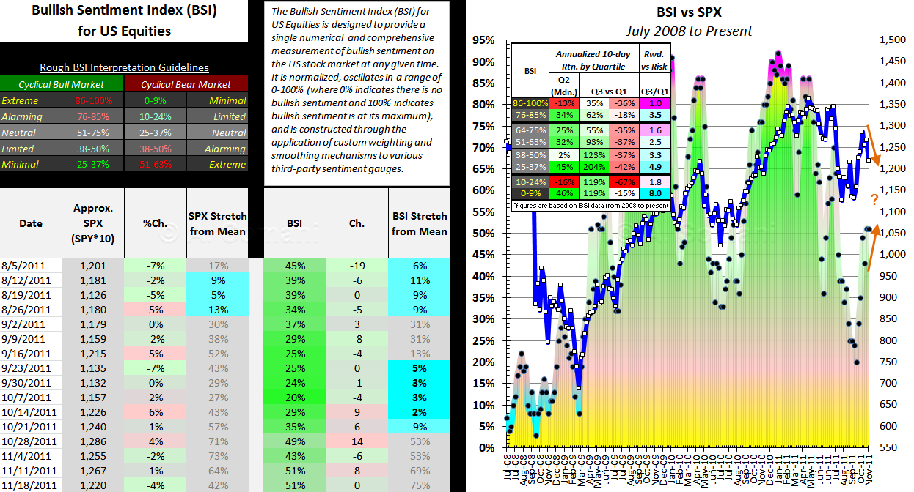
BSI for US Equities – Summary
The BSI stood unchanged at the end of this week to close at 51%. Meanwhile, the SPX corrected about 4%, and now sits over 5% below its high from a few weeks ago.

Interestingly, the BSI is noticeably positively diverging from the SPX on a multi-week basis, currently, as I’ve highlighted in the snapshot above. One would assume this is necessarily bearish, but, in fact, history suggests such an assumption may not be a wise one. For example, a similarly noticeable but negative multi-week divergence occurred following the Aug. low in the SPX, preceding a re-test of that low in Oct (as opposed to a continued move higher). The point is, one way or another, we know that the BSI and SPX will soon be moving in the same direction again, but how that occurs (the SPX changing direction or the BSI changing direction) remains to be seen.

The current level of the BSI should be interpreted within the context of the current cyclical trend:

- Within the context of a cyclical bull market, the current level of the BSI suggests bullish sentiment is neutral – so, there are apparently still many traders and investors who would risk buying into the market that have not yet done so.

- Within the context of a cyclical bear market, the current level of the BSI suggests bullish sentiment is extreme – so, apparently the vast majority of traders and investors who would risk buying into the market have already done so.

Cautionary Note on Interpretation: The Bullish Sentiment Index (BSI) for US Equities and its associated indicators (“SPX Stretch from Mean” and “BSI Stretch from Mean”) are perhaps best used as a blunt and continuous (as opposed to discrete) indication as to the general market mood toward US equities, which can help a contrarian trader or investor to decide when to increase or hedge/decrease US equities exposure so as to help manage risk effectively and thereby maximize risk-adjusted returns. In a cyclical bull market, it is not unusual for the BSI and its associated indicators to remain elevated for extended periods without the market declining in any significant way. Conversely, in cyclical bear markets, it is not unusual for the BSI and its associated indicators to remain depressed for extended periods without the market rising in any significant way. Furthermore, the BSI and its associated indicators represent merely one suite of tools a trader or investor can use to analyze markets, and should not be interpreted except in combination with the message being delivered by one or more other suites of tools that the trader or investor feels confident in comprehensively analyzing markets with.

Disclaimer: The contents of this report do not represent trading or investment advice or recommendations. Information presented is believed to be accurate but cannot be guaranteed to be accurate. The Bullish Sentiment Index (BSI) for US Equities and its associated indicators (“SPX Stretch from Mean” and “BSI Stretch from Mean”) should not be used as a basis for trading or investment decisions and are shared to readers purely for entertainment purposes at the present time. Please consult your Registered Investment Advisor before making any trading or investment decisions and please remember that the publisher of this report bears no responsibility for your trading and investment decisions.

